Model coefficients for the best *N*-mixture model predicting abundance of Alder Flycatcher *Empidonax alnorum* at the 50-m scale (AIC= 172.04) (A), 150-m scale (AIC= 171.61) (C), and 500-m scale (AIC= 168.14) (E), along with predicted abundances of this species in the Kirby grid from these respective models (B,D,F).

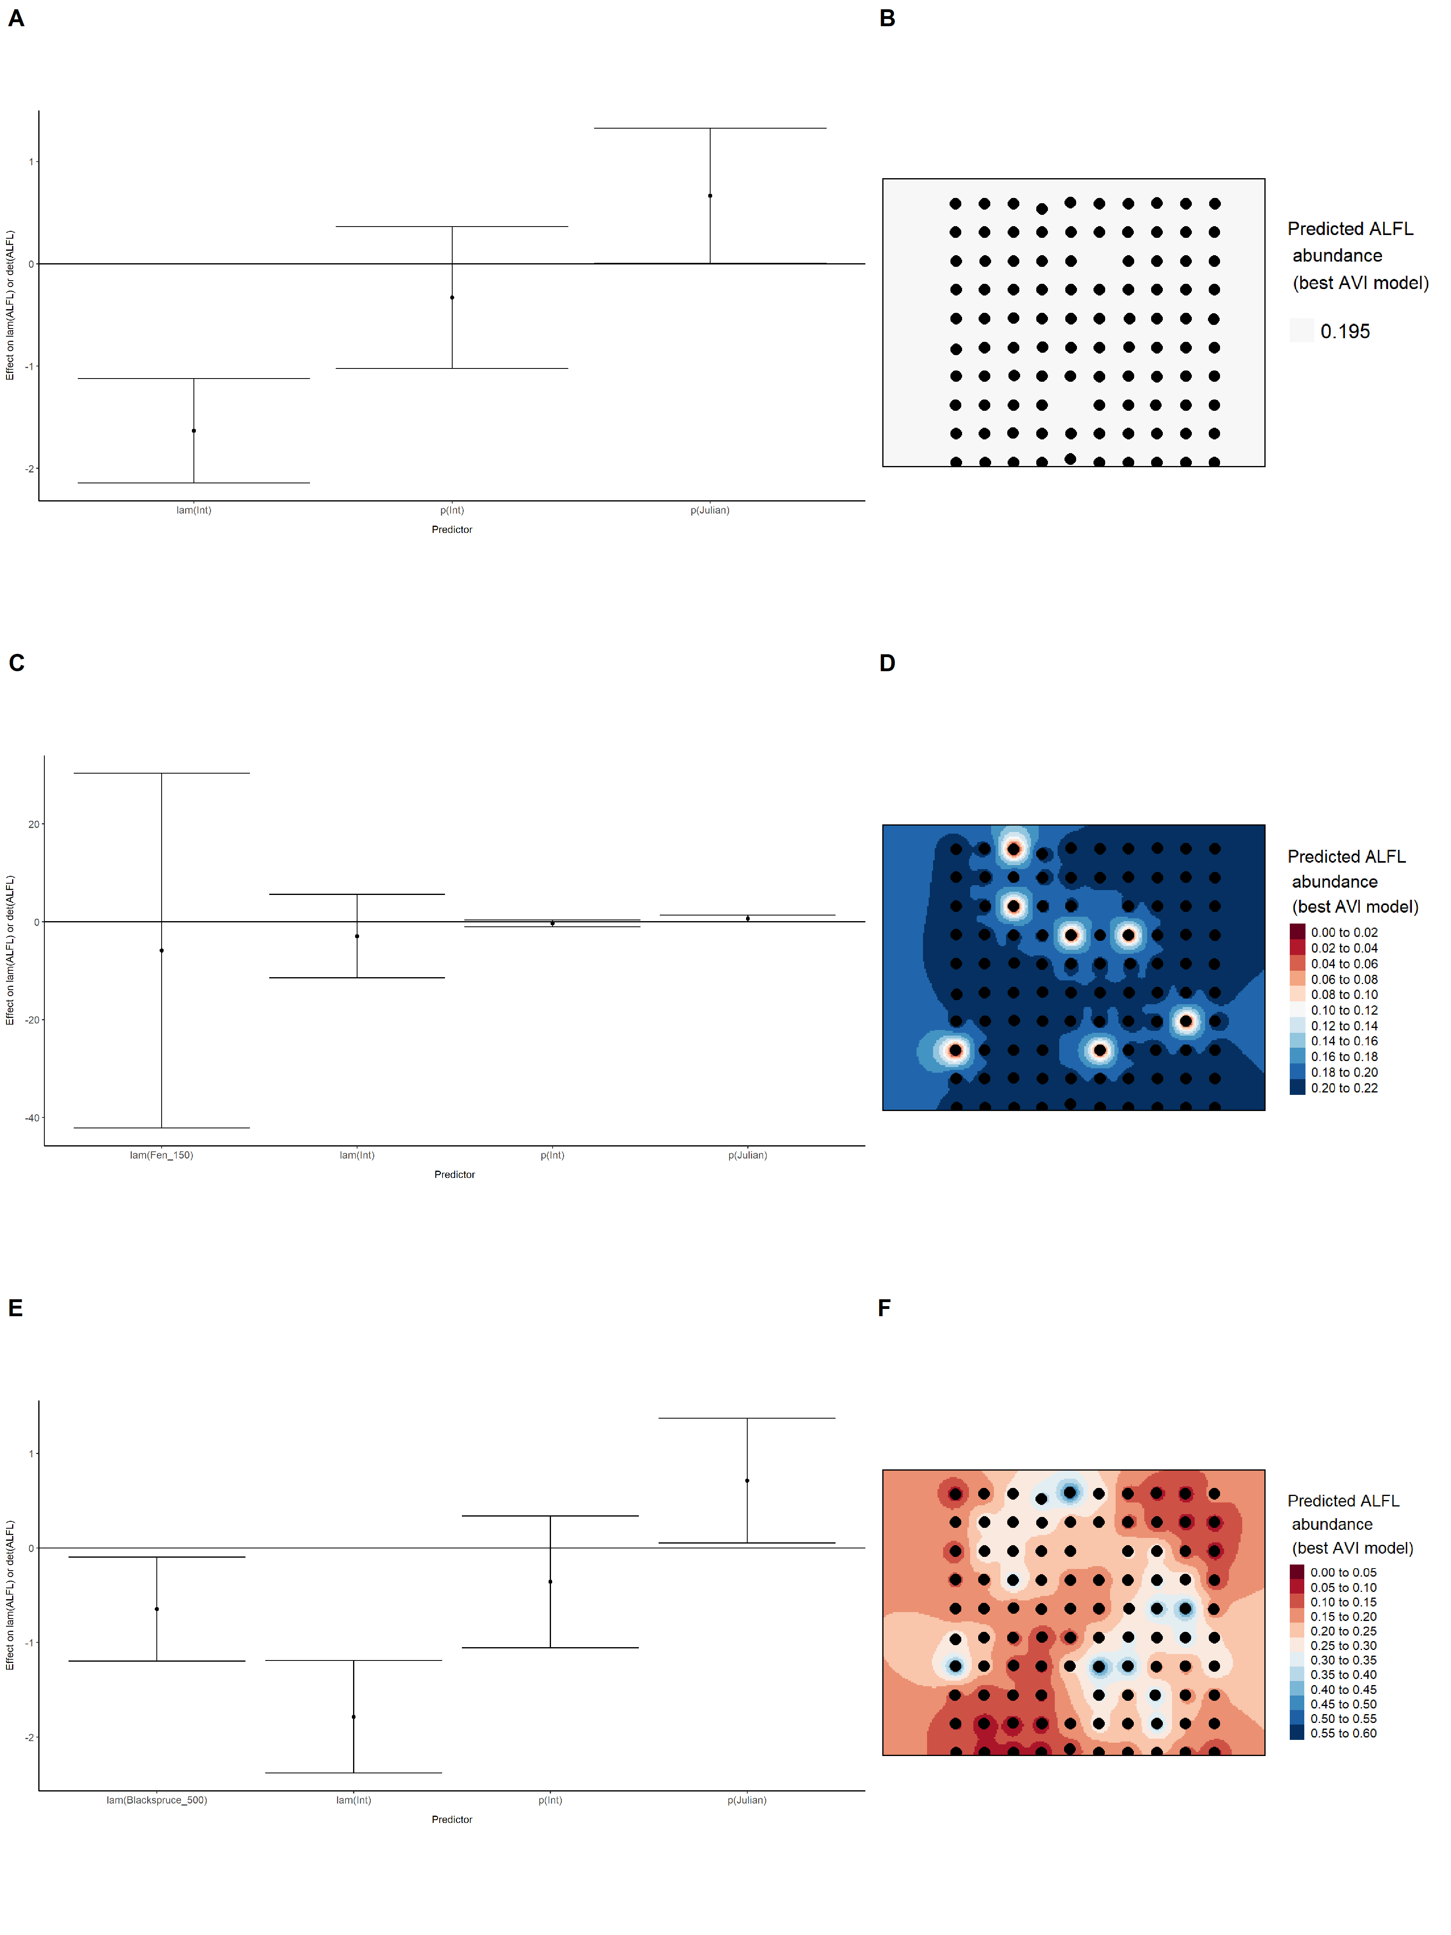

Model coefficients for the best *N*-mixture model predicting abundance of American Robin *Turdus migratorius* at the 50-m scale (AIC= 289.41) (A), 150-m scale (AIC= 291.6) (C), and 500-m scale (AIC= 284.87) (E), along with predicted abundances of this species in the Kirby grid from these respective models (B,D,F).

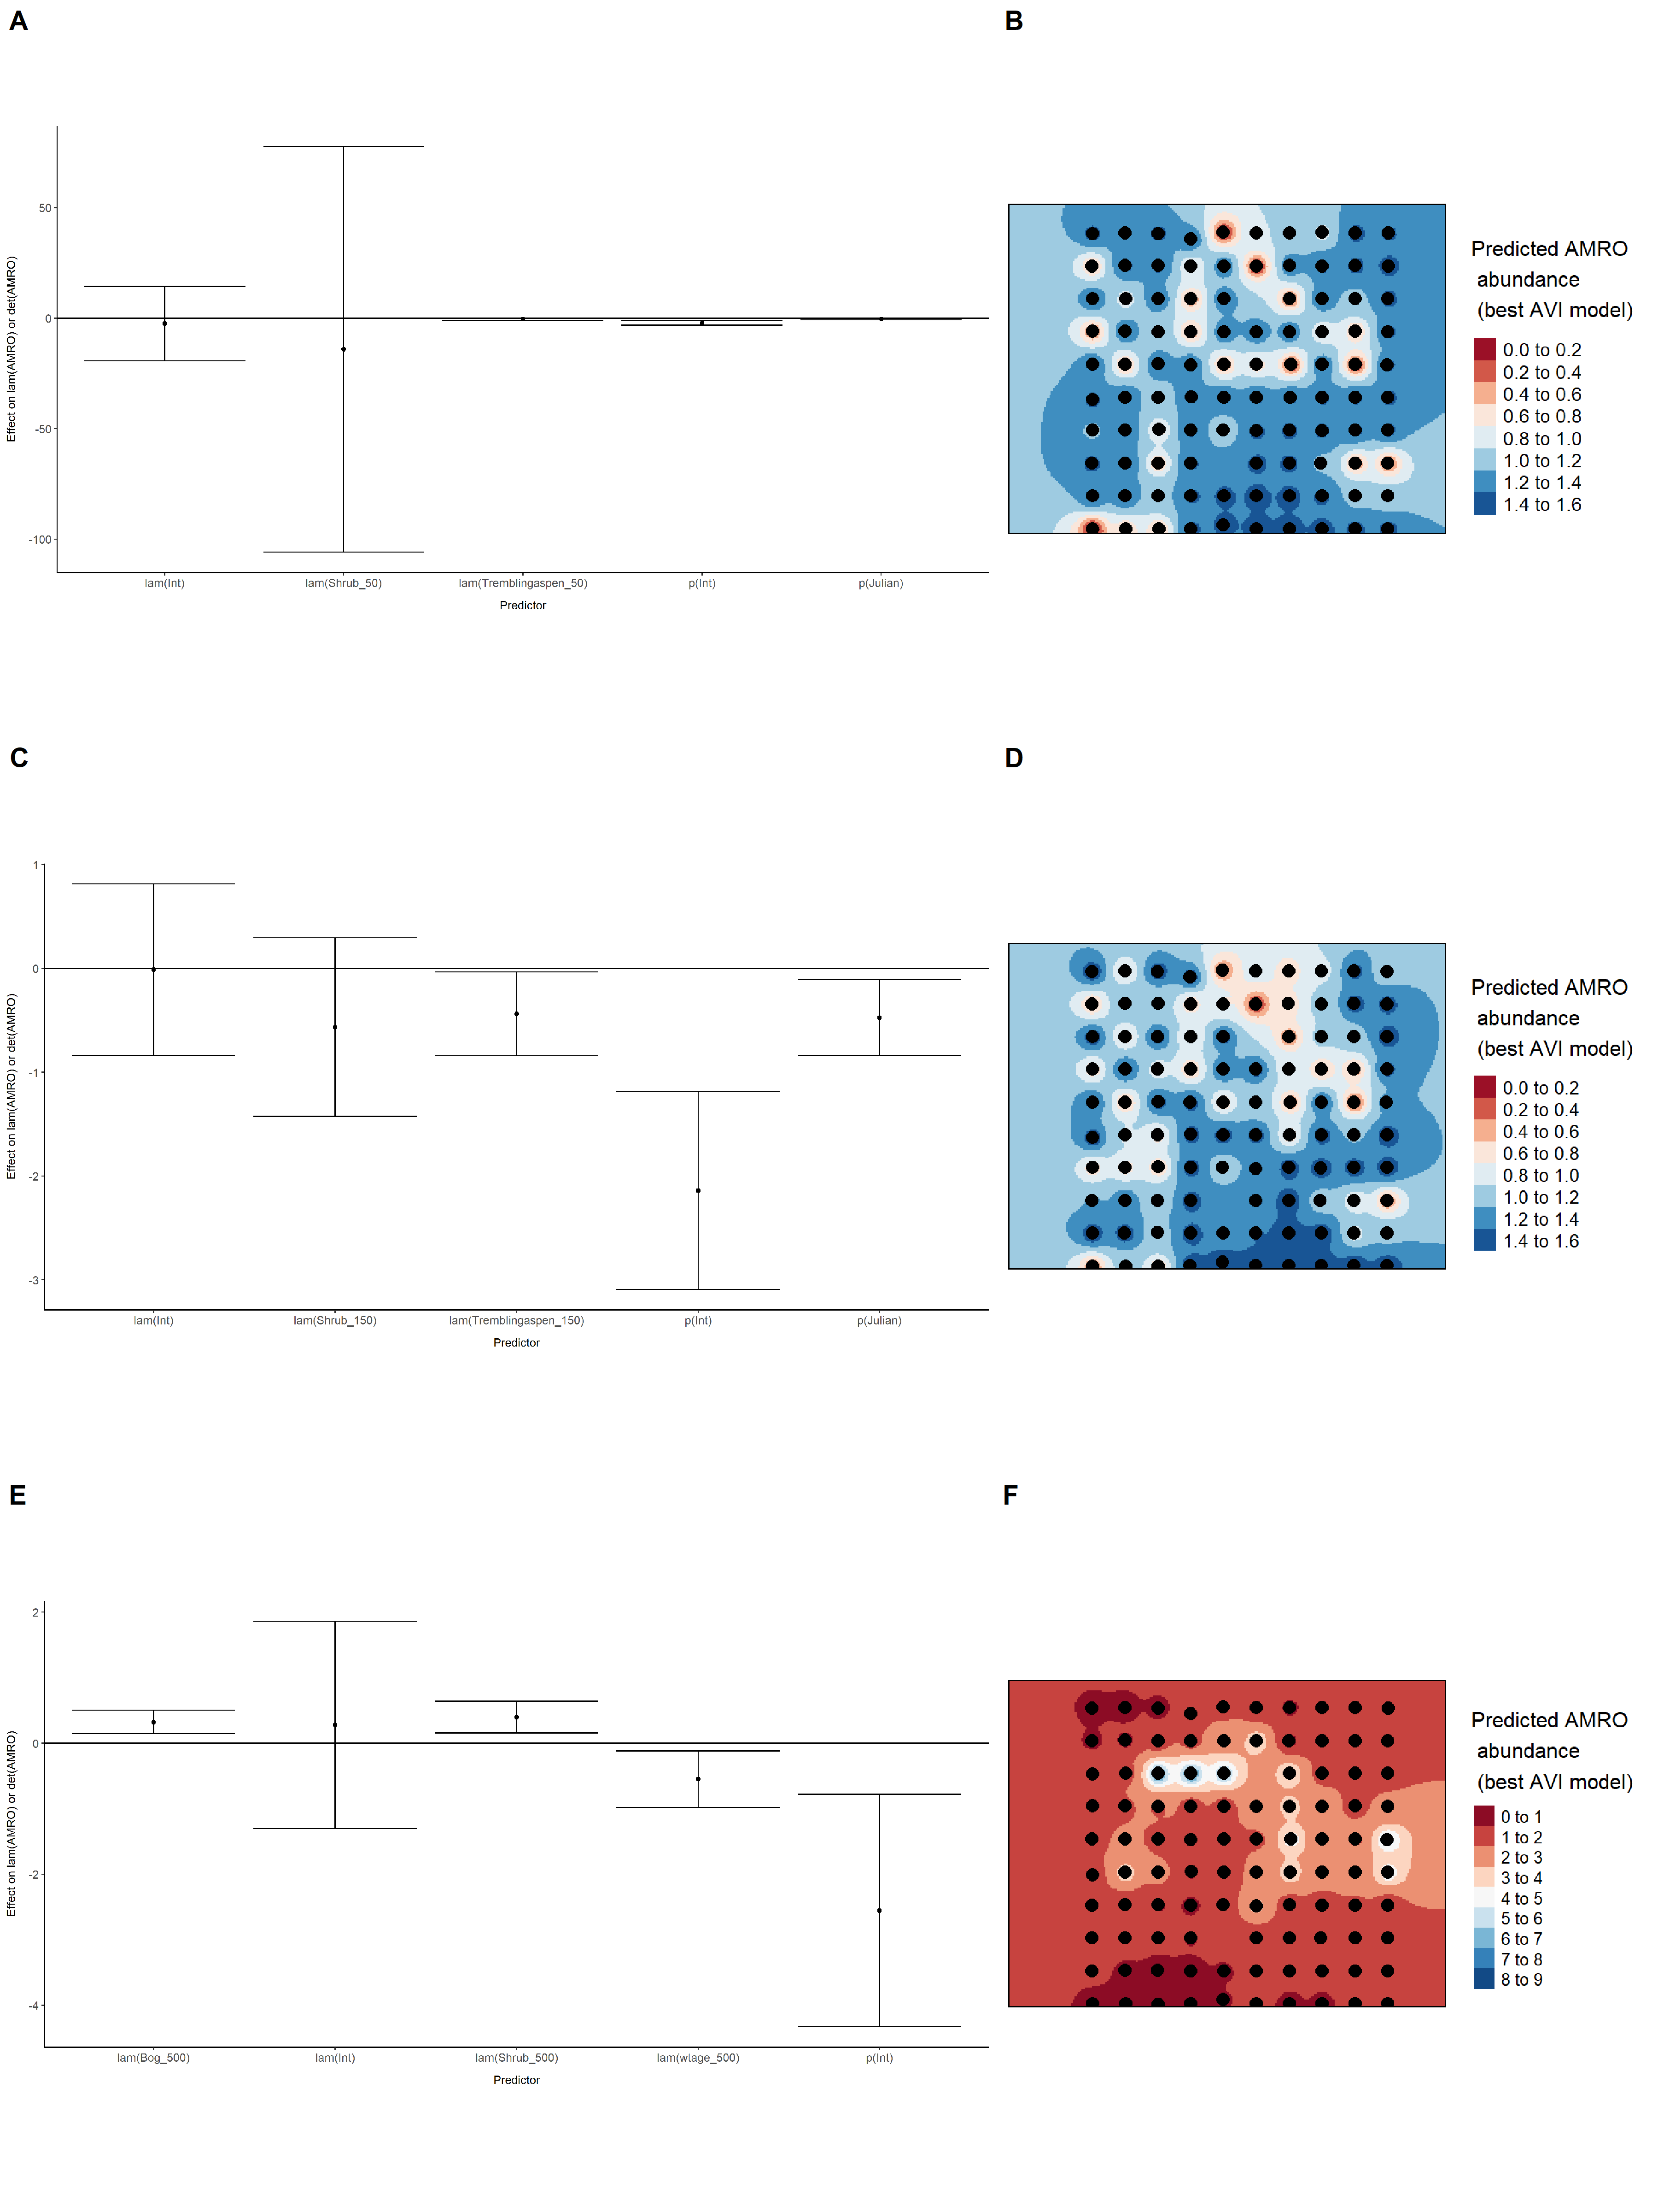

Model coefficients for the best *N*-mixture model predicting abundance of Boreal Chickadee *Poecile hudsonicus* at the 50-m scale (AIC= 126.92) (A), 150-m scale (AIC= 129.92) (C), and 500-m scale (AIC= 135.31) (E), along with predicted abundances of this species in the Kirby grid from these respective models (B,D,F).

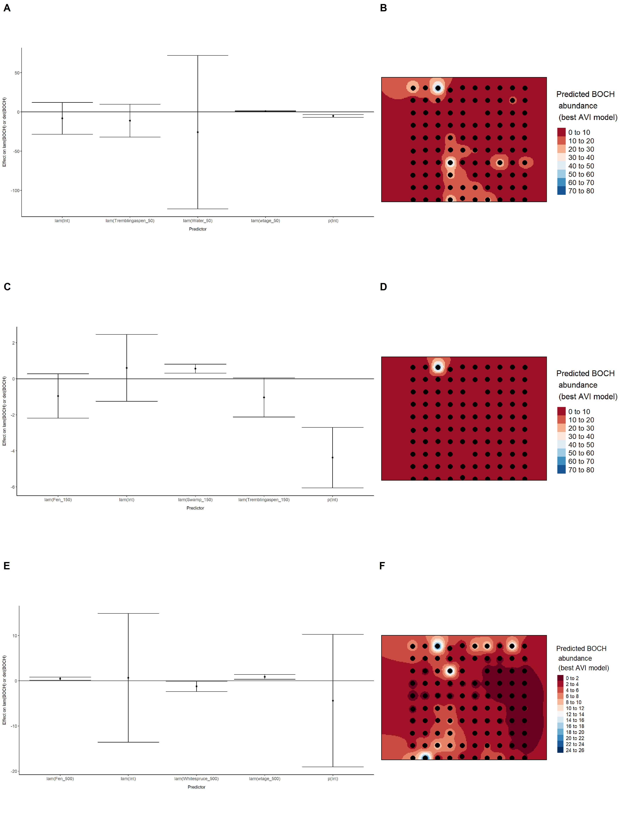

Model coefficients for the best *N*-mixture model predicting abundance of Cedar Waxwing *Bombycilla cedrorum* at the 50-m scale (AIC= 126.2) (A), 150-m scale (AIC= 118.63) (C), and 500-m scale (AIC= 123.4) (E), along with predicted abundances of this species in the Kirby grid from these respective models (B,D,F).

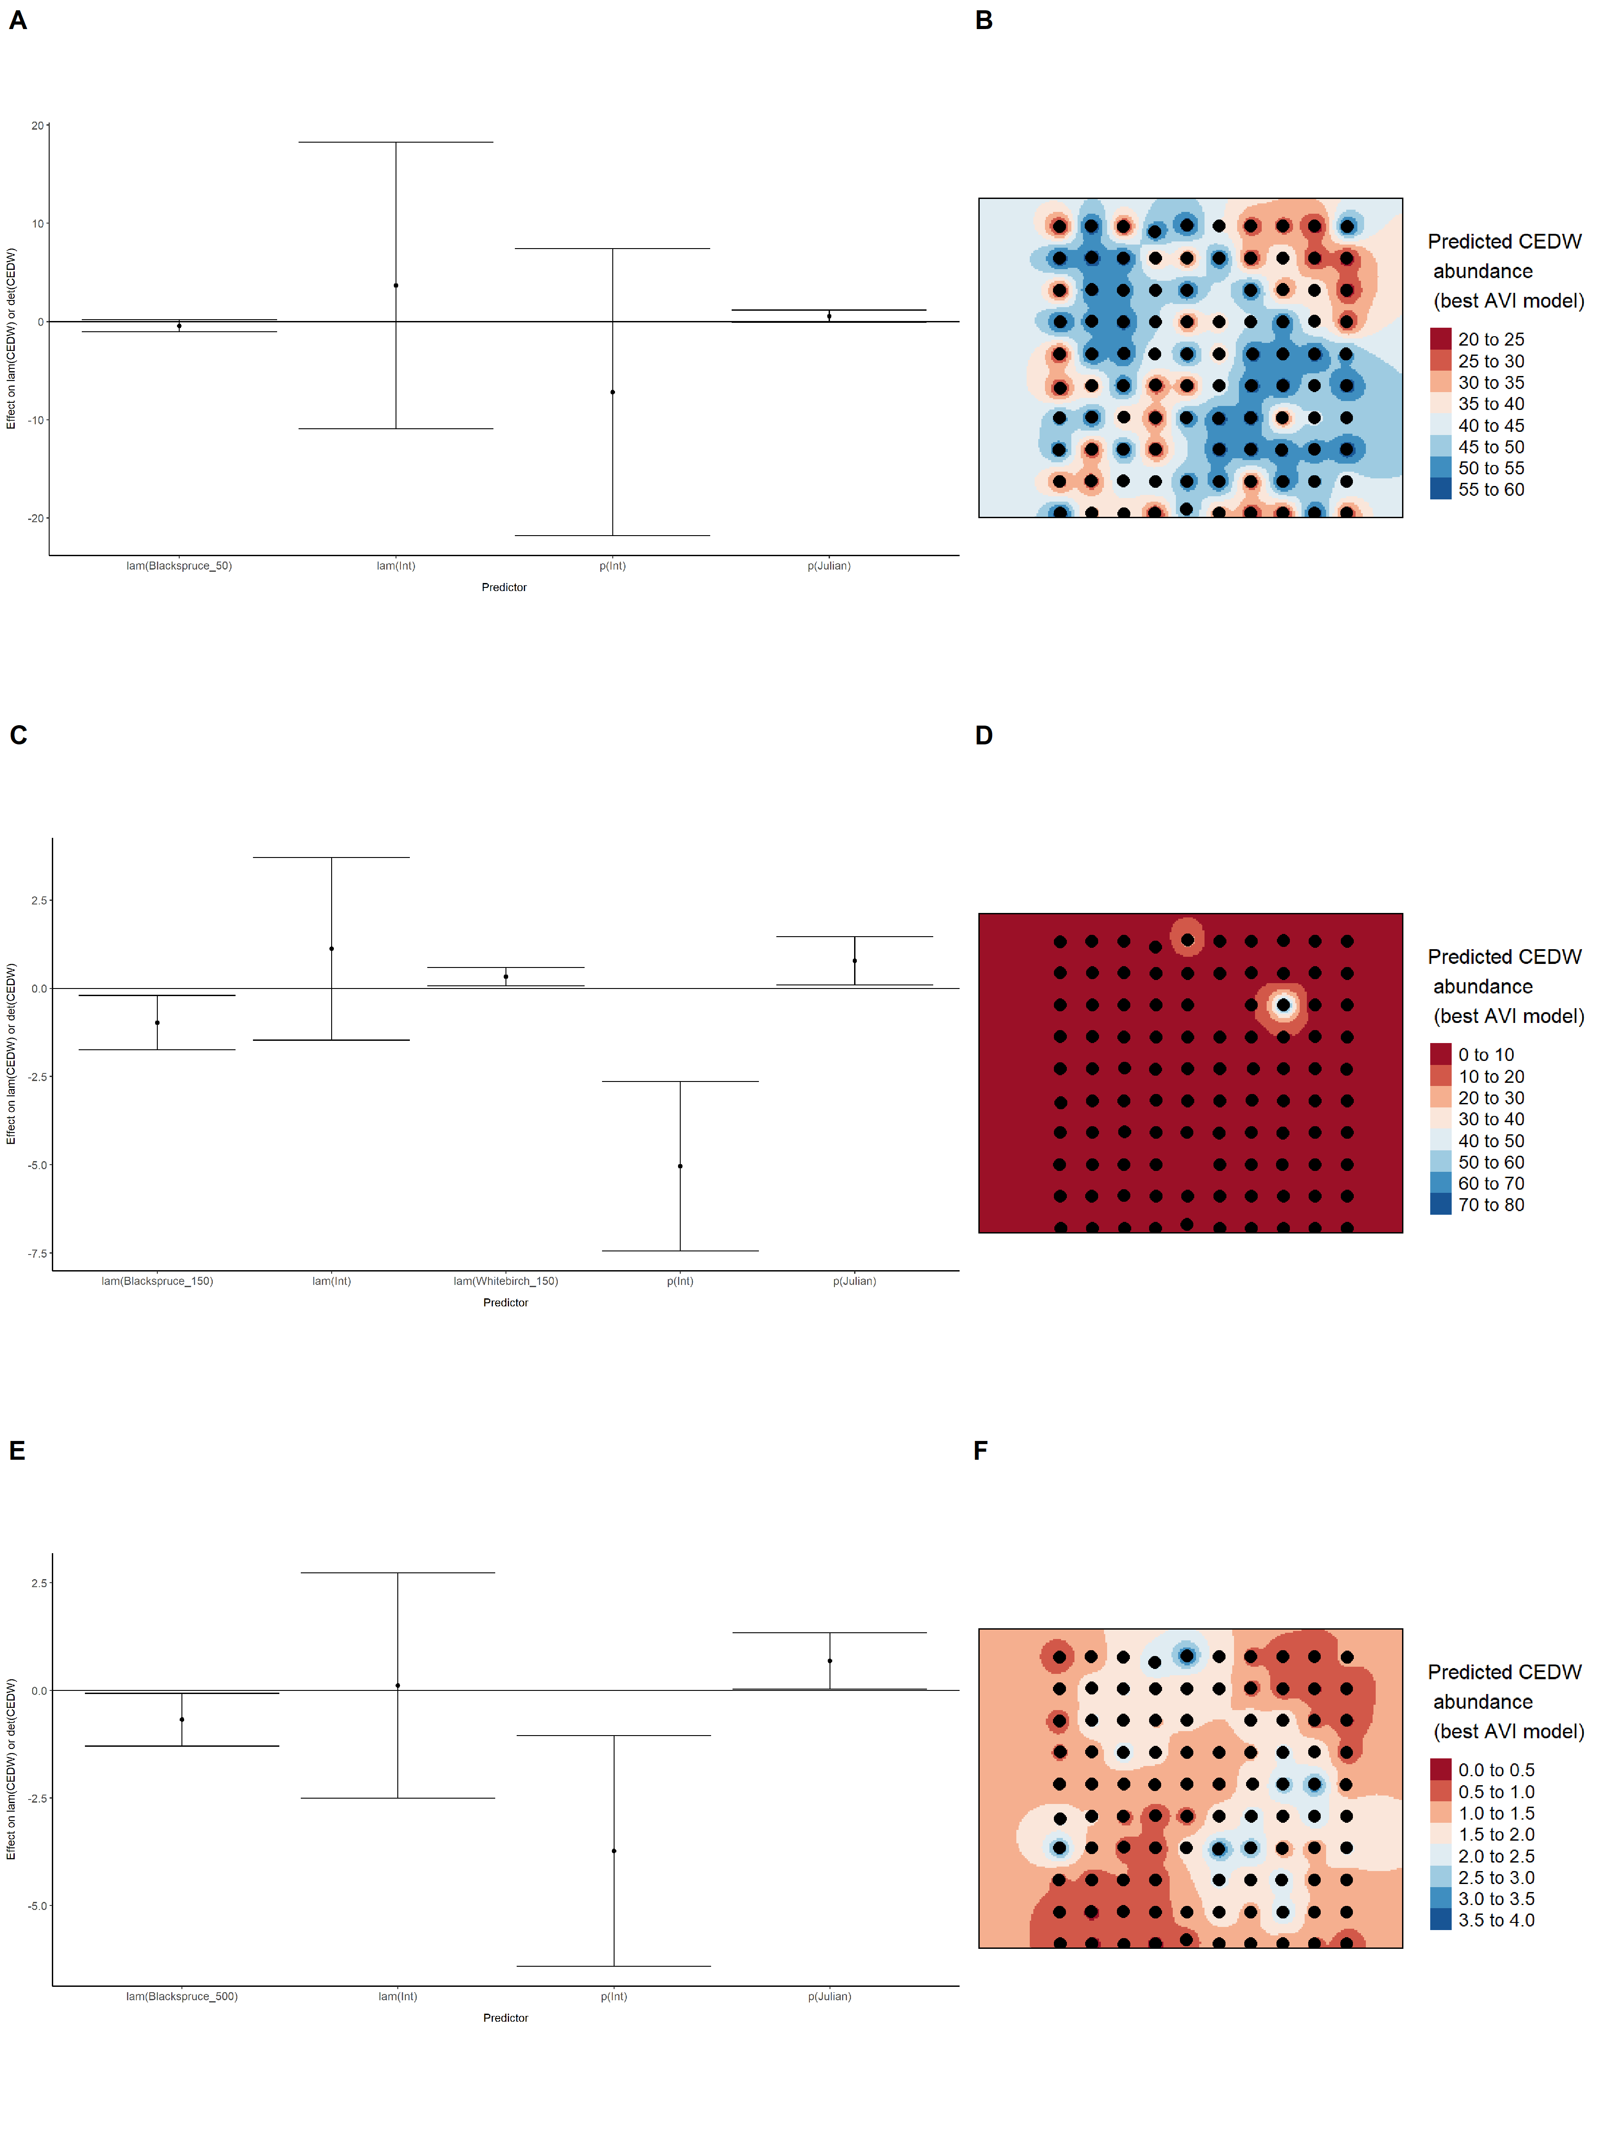

Model coefficients for the best *N*-mixture model predicting abundance of Chipping Sparrow *Spizella passerina* at the 50-m scale (AIC= 566.71) (A), 150-m scale (AIC= 567.49) (C), and 500-m scale (AIC= 576.64) (E), along with predicted abundances of this species in the Kirby grid from these respective models (B,D,F).

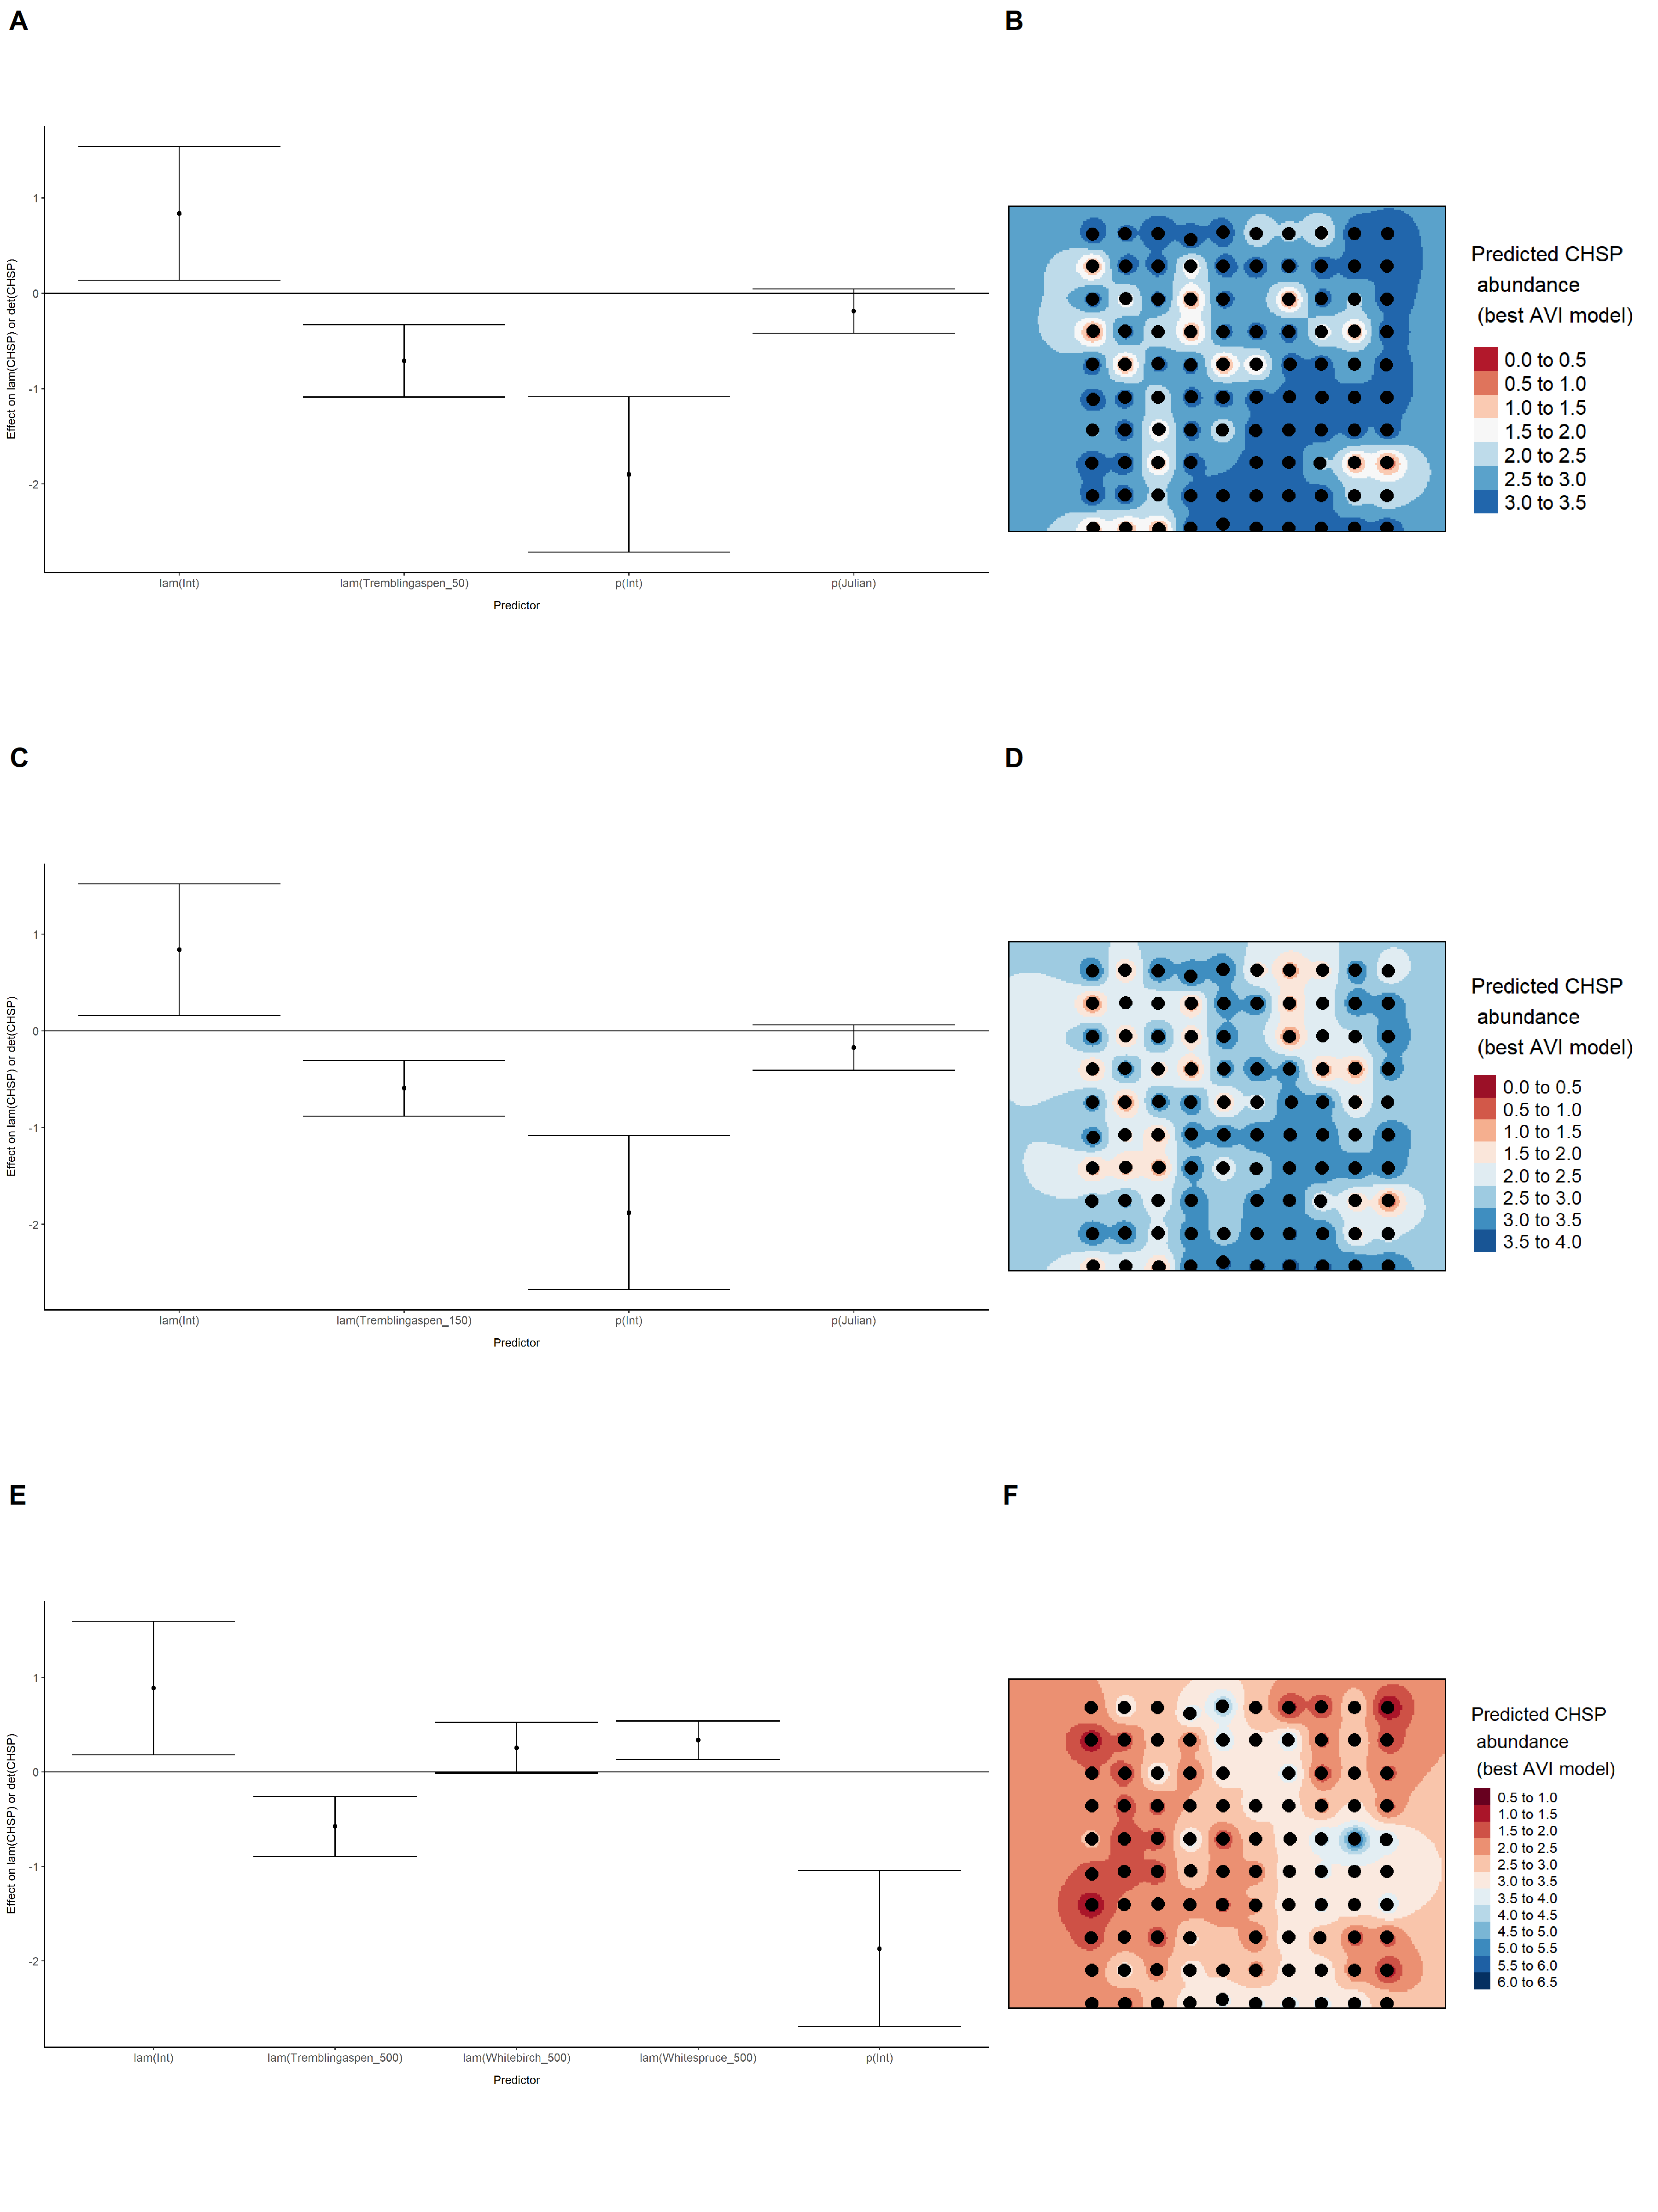

Model coefficients for the best *N*-mixture model predicting abundance of Common Yellowthroat *Geothlypis trichas* at the 50-m scale (AIC= 109.5) (A), 150-m scale (AIC= 111) (C), and 500-m scale (AIC= 118.97) (E), along with predicted abundances of this species in the Kirby grid from these respective models (B,D,F).

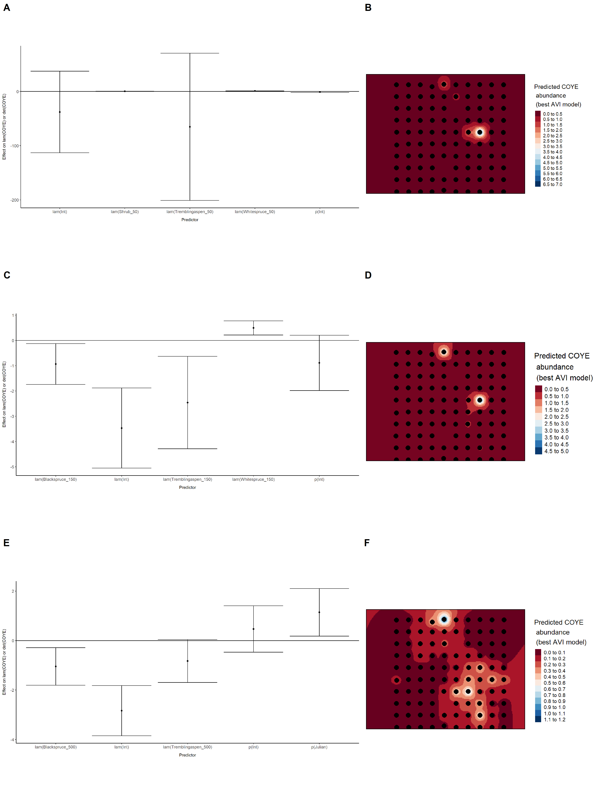

Model coefficients for the best *N*-mixture model predicting abundance of Dark-eyed Junco *Junco hyemalis* at the 50-m scale (AIC= 426.85) (A), 150-m scale (AIC= 422) (C), and 500-m scale (AIC= 437.79) (E), along with predicted abundances of this species in the Kirby grid from these respective models (B,D,F).

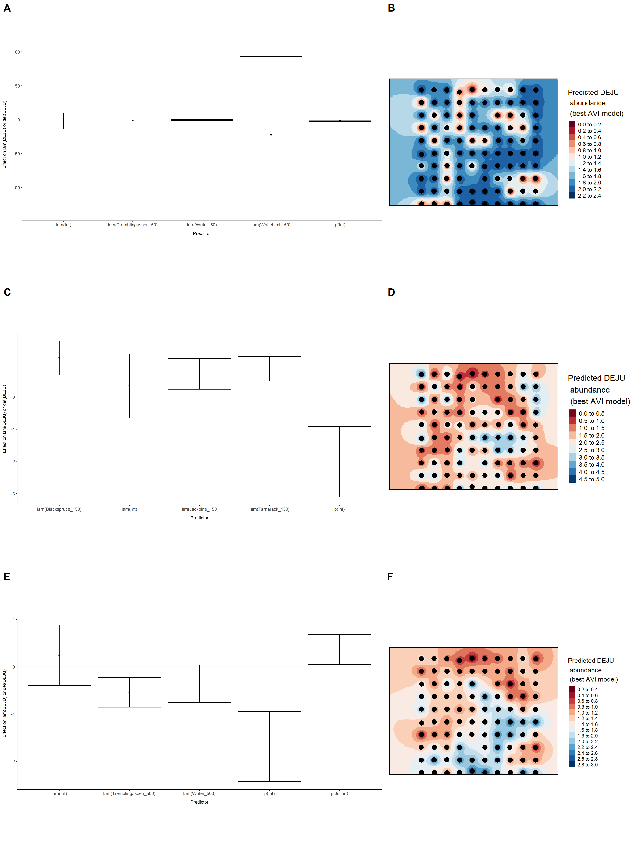

Model coefficients for the best *N*-mixture model predicting abundance of Gray Jay *Perisoreus canadensis* at the 50-m scale (AIC= 466.06) (A), 150-m scale (AIC= 459.33) (C), and 500-m scale (AIC= 465.1) (E), along with predicted abundances of this species in the Kirby grid from these respective models (B,D,F).

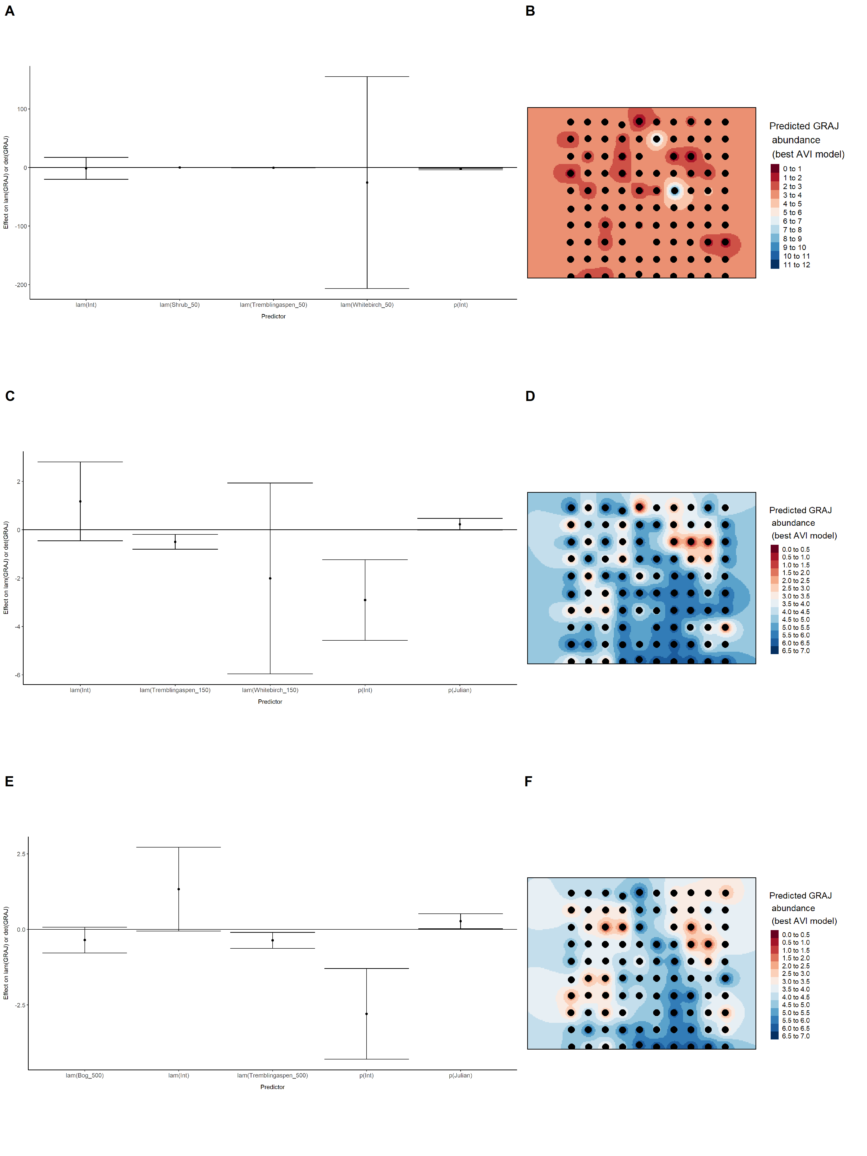

Model coefficients for the best *N*-mixture model predicting abundance of Hermit Thrush *Catharus guttatus* at the 50-m scale (AIC= 692.28) (A), 150-m scale (AIC= 688.17) (C), and 500-m scale (AIC= 693.53) (E), along with predicted abundances of this species in the Kirby grid from these respective models (B,D,F).

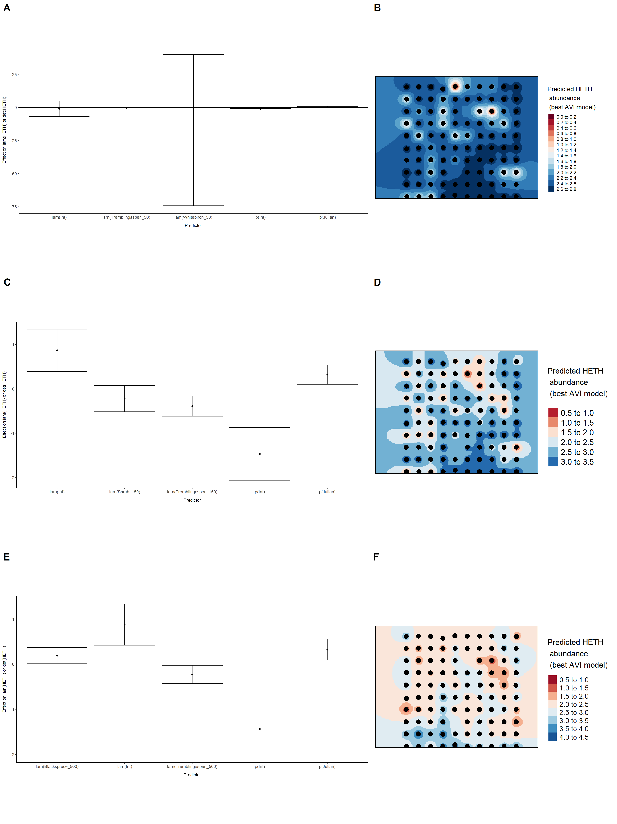

Model coefficients for the best *N*-mixture model predicting abundance of Le Conte’s Sparrow *Ammodramus lecontei* at the 50-m scale (AIC= 251.72) (A), 150-m scale (AIC= 242.8) (C), and 500-m scale (AIC= 243.47) (E), along with predicted abundances of this species in the Kirby grid from these respective models (B,D,F).

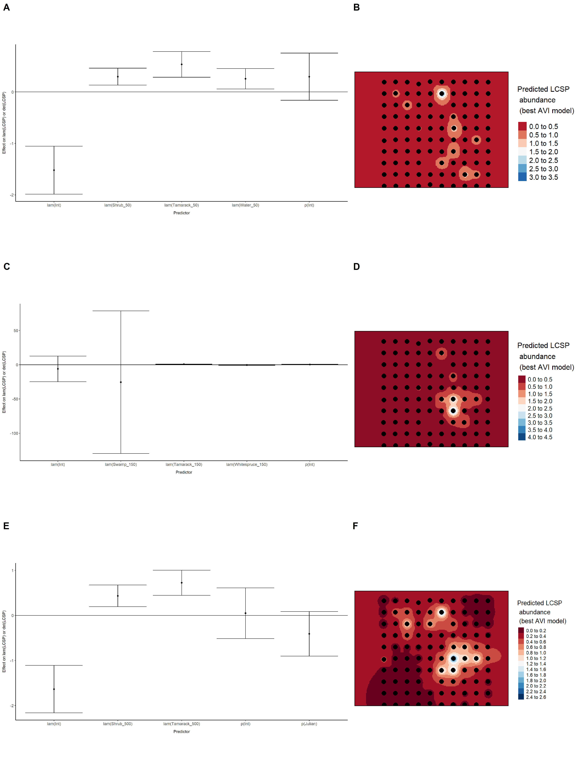

Model coefficients for the best *N*-mixture model predicting abundance of Lincoln’s Sparrow *Melospiza lincolnii* at the 50-m scale (AIC= 473.99) (A), 150-m scale (AIC= 464.25) (C), and 500-m scale (AIC= 471.37) (E), along with predicted abundances of this species in the Kirby grid from these respective models (B,D,F).

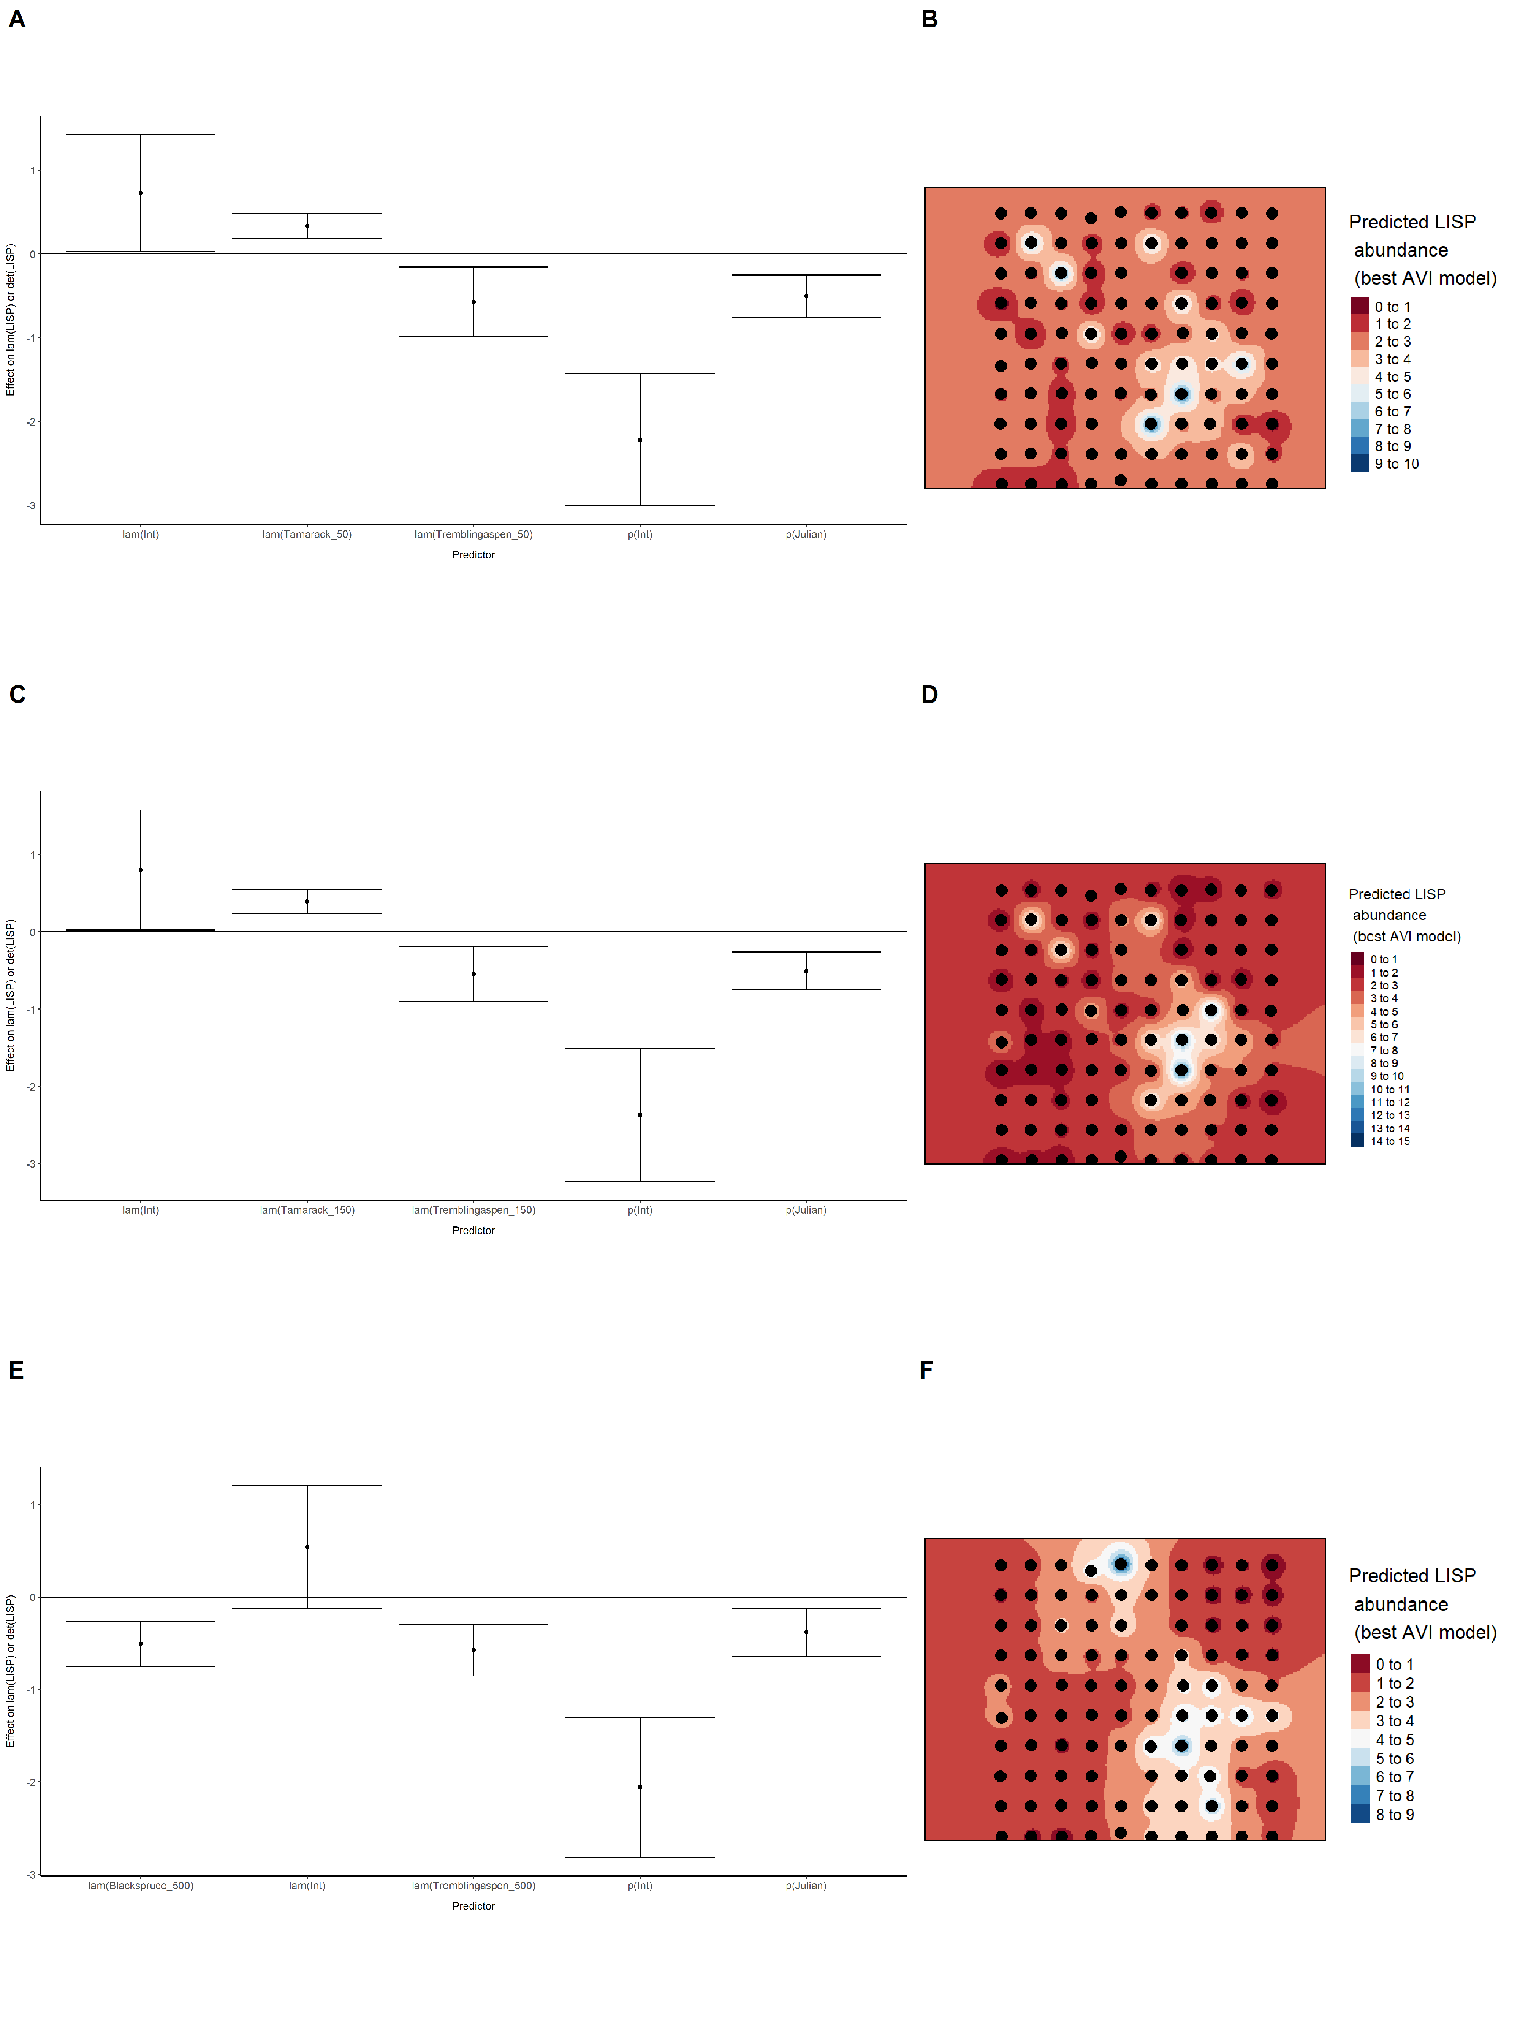

Model coefficients for the best *N*-mixture model predicting abundance of Olive-sided Flycatcher *Contopus cooperi* at the 50-m scale (AIC= 152.68) (A), 150-m scale (AIC= 151.83) (C), and 500-m scale (AIC= 133.74) (E), along with predicted abundances of this species in the Kirby grid from these respective models (B,D,F).

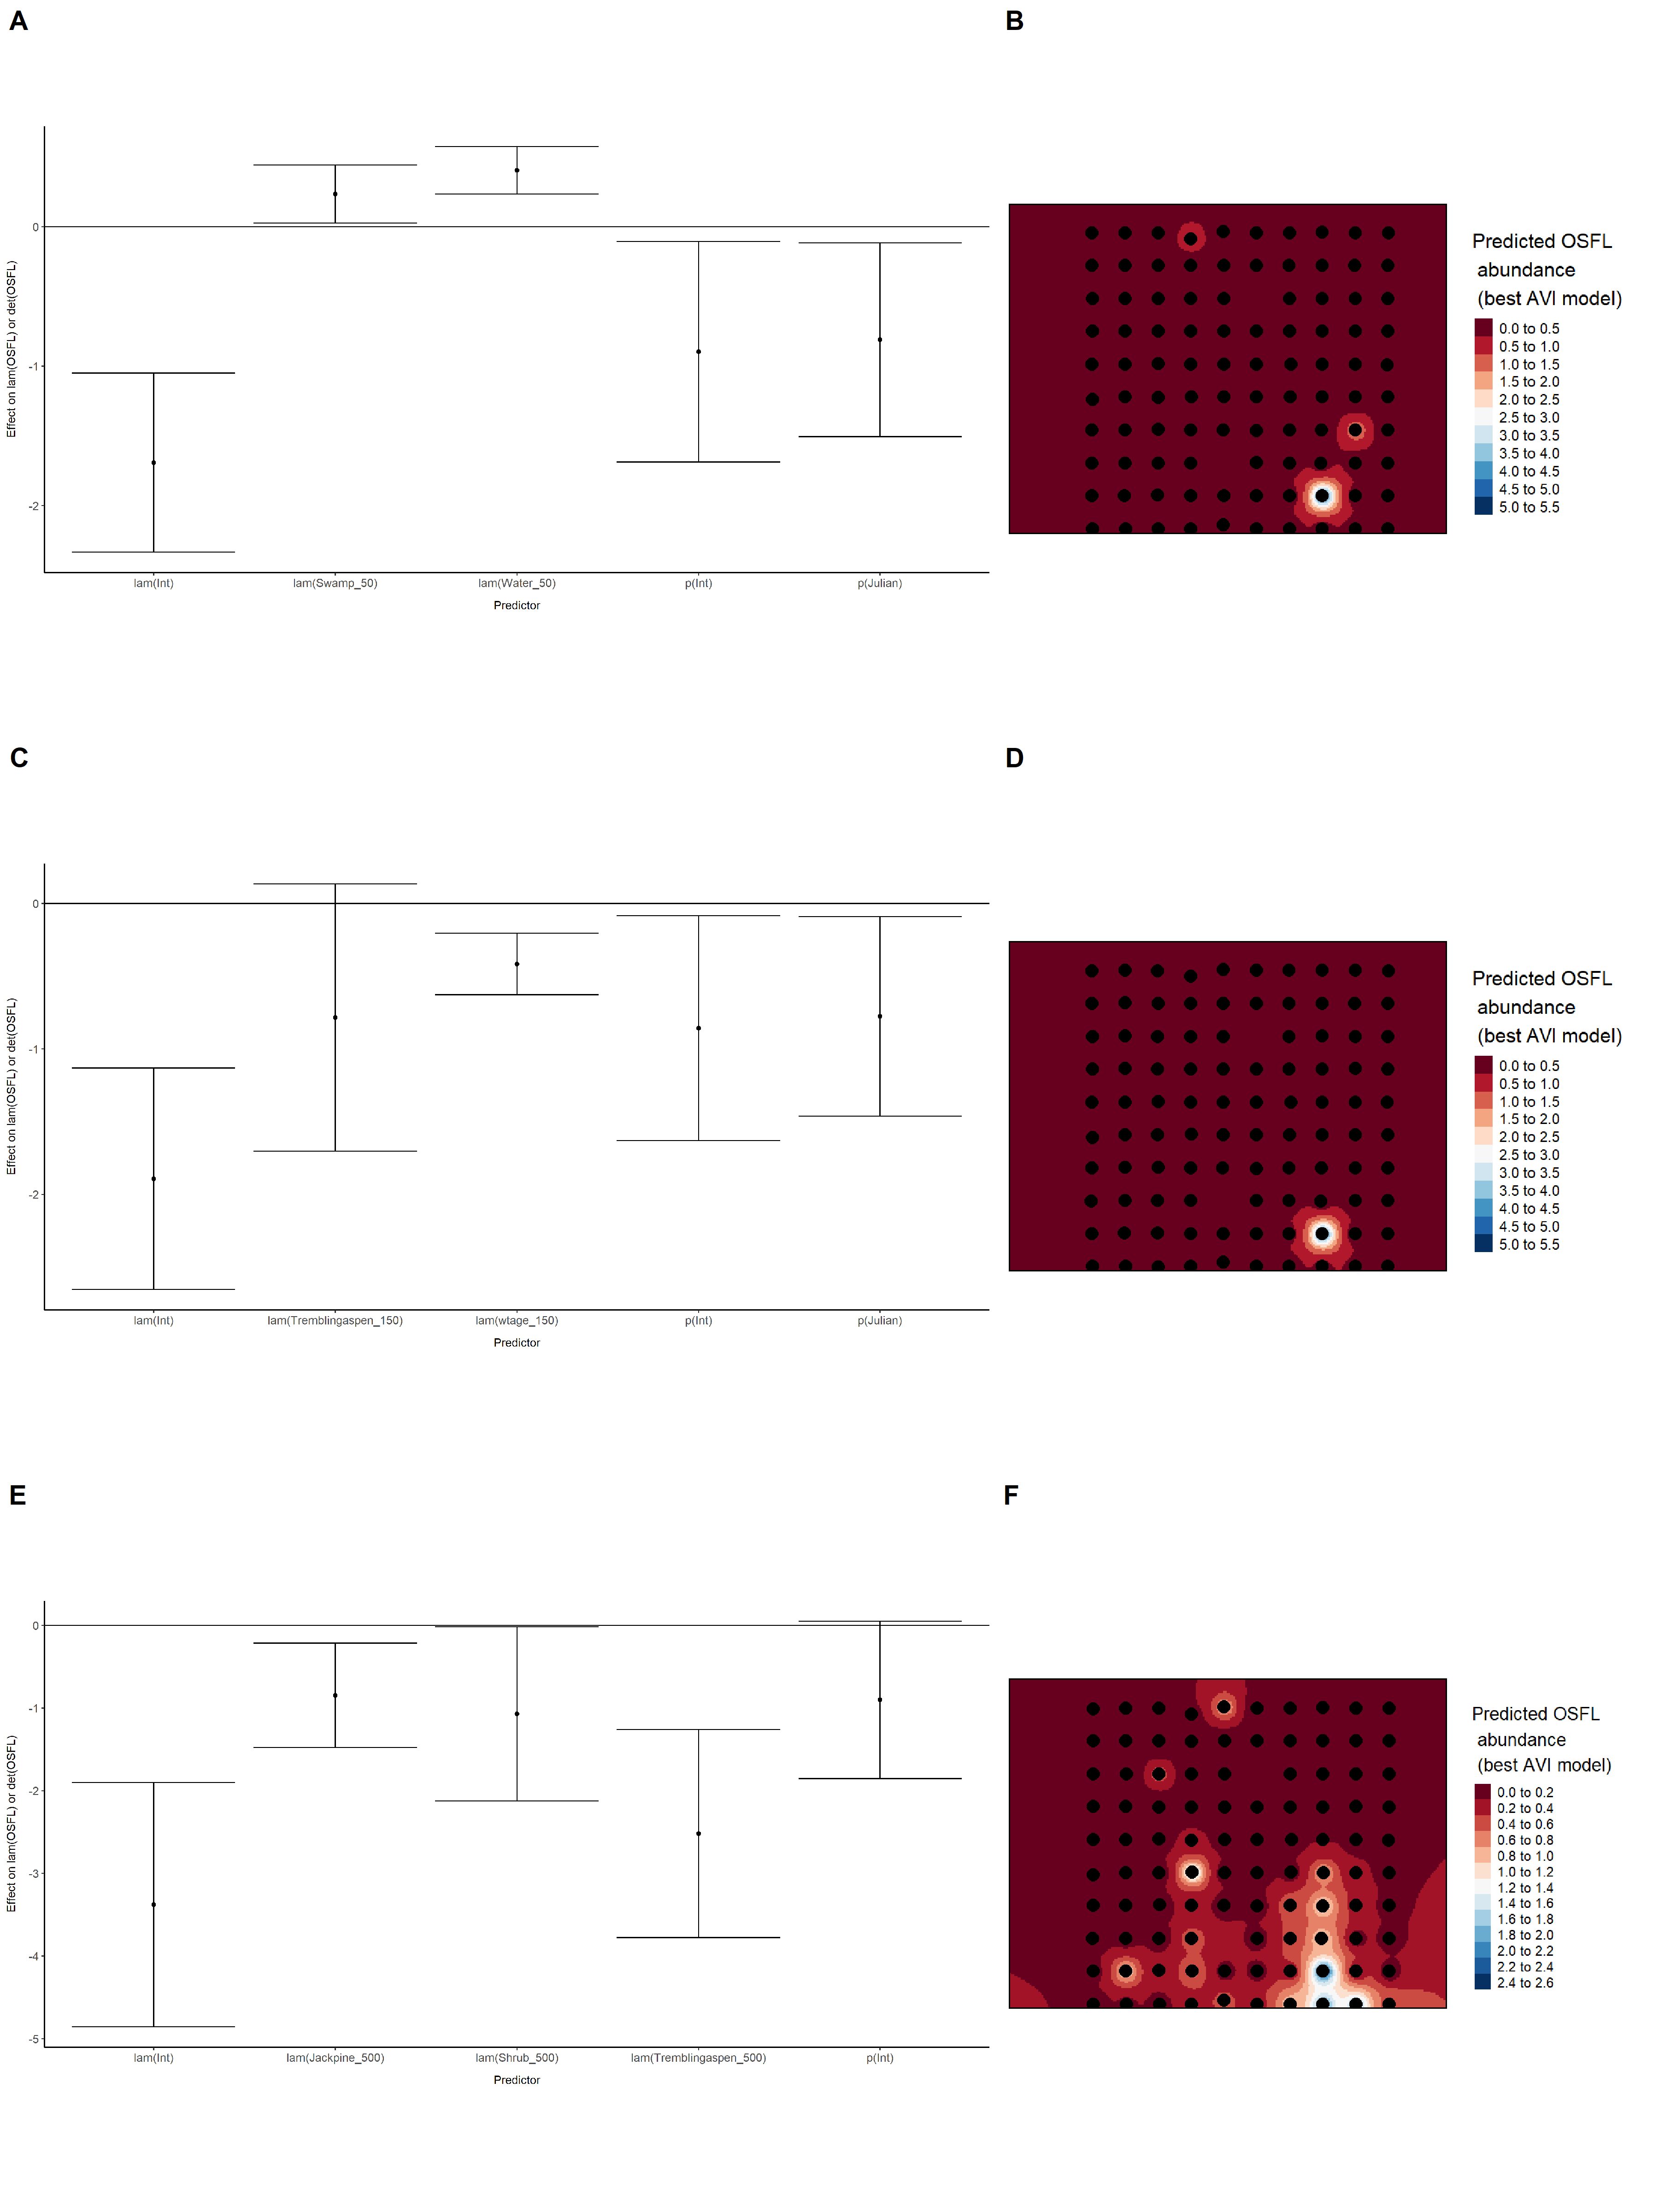

Model coefficients for the best *N*-mixture model predicting abundance of Ovenbird *Seiurus aurocapillus* at the 50-m scale (AIC= 332.04) (A), 150-m scale (AIC= 323.67) (C), and 500-m scale (AIC= 321.36) (E), along with predicted abundances of this species in the Kirby grid from these respective models (B,D,F).

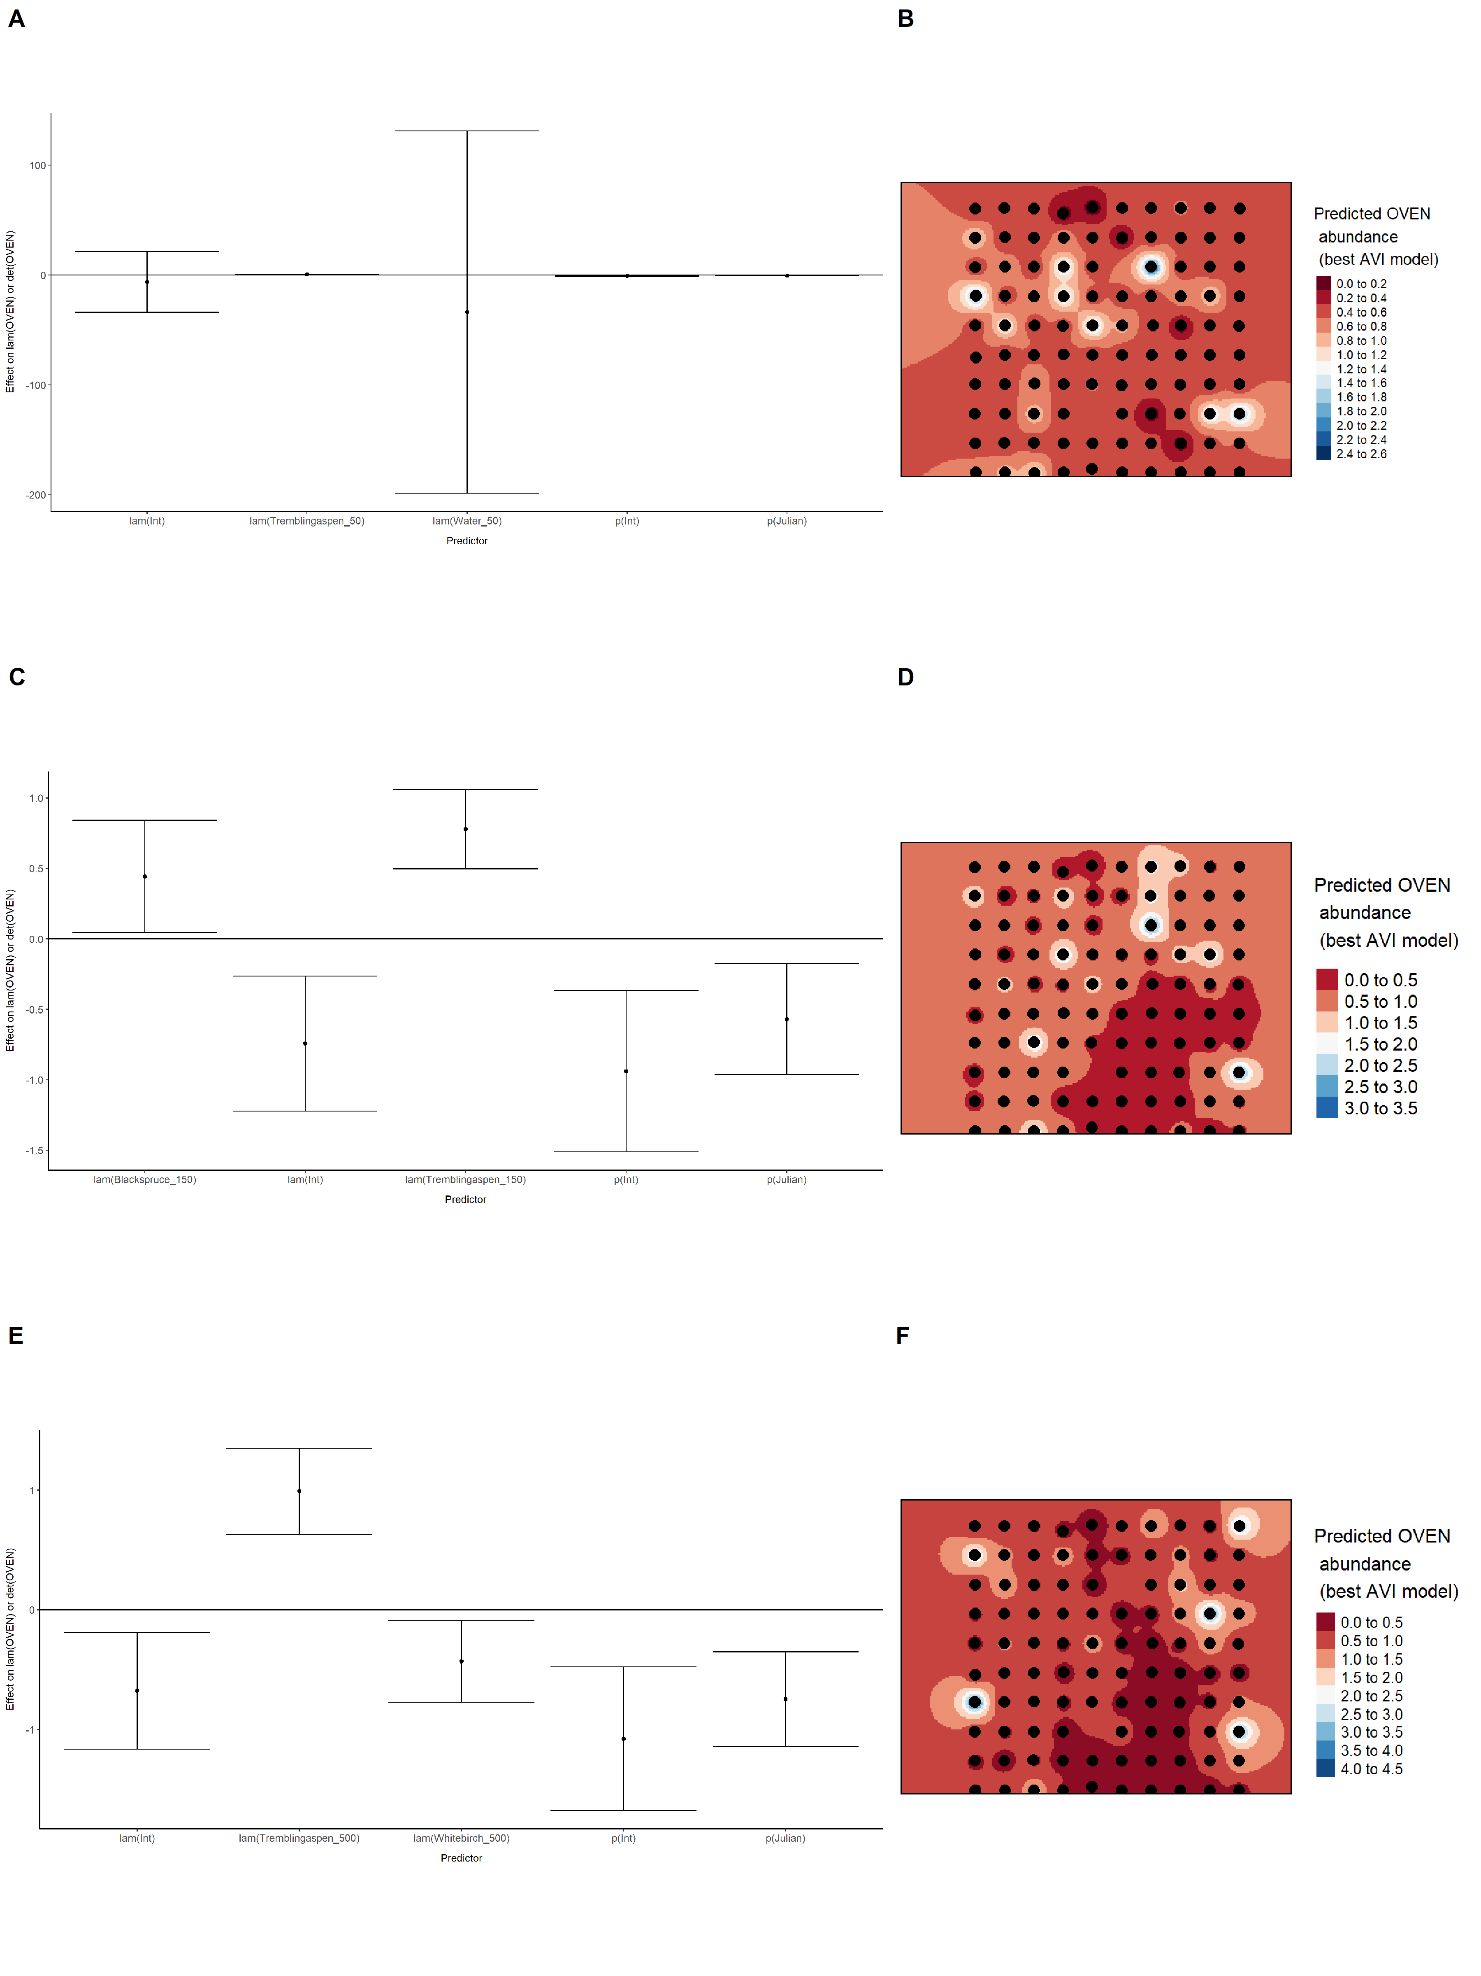

Model coefficients for the best *N*-mixture model predicting abundance of Palm Warbler *Setophaga palmarum* at the 50-m scale (AIC= 168.49) (A), 150-m scale (AIC= 153.98) (C), and 500-m scale (AIC= 164.2) (E), along with predicted abundances of this species in the Kirby grid from these respective models (B,D,F).

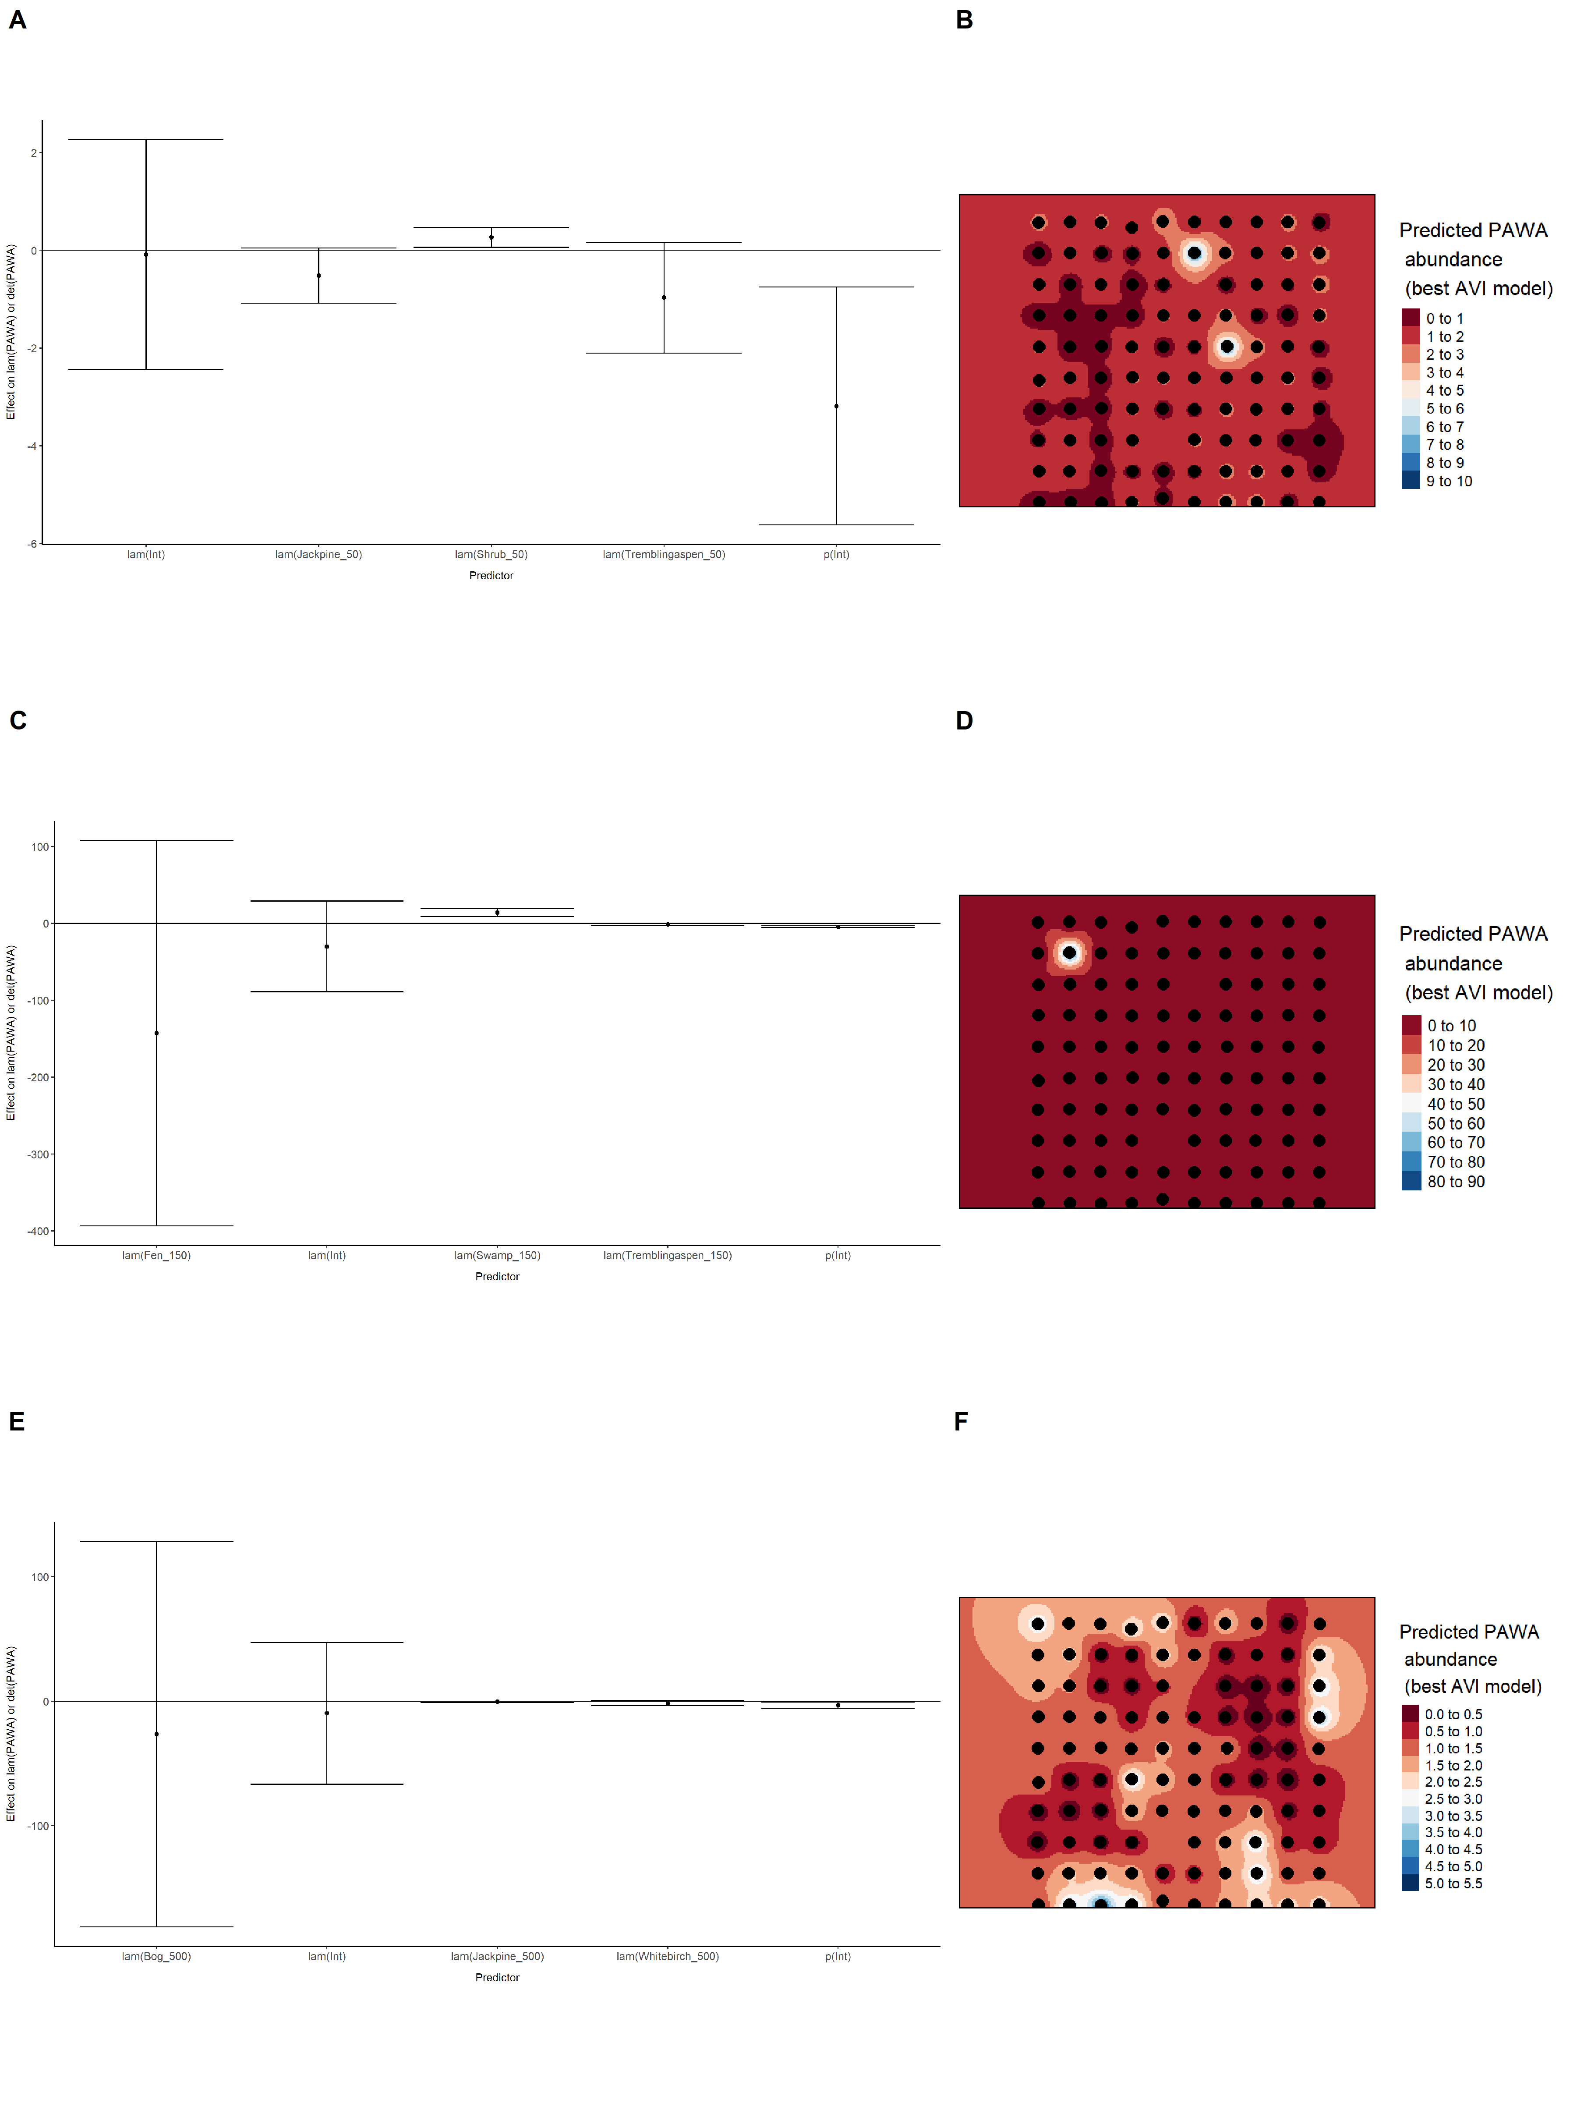

Model coefficients for the best *N*-mixture model predicting abundance of Red-eyed Vireo *Vireo olivaceus* at the 50-m scale (AIC= 289.88) (A), 150-m scale (AIC= 282.5) (C), and 500-m scale (AIC= 265.41) (E), along with predicted abundances of this species in the Kirby grid from these respective models (B,D,F).

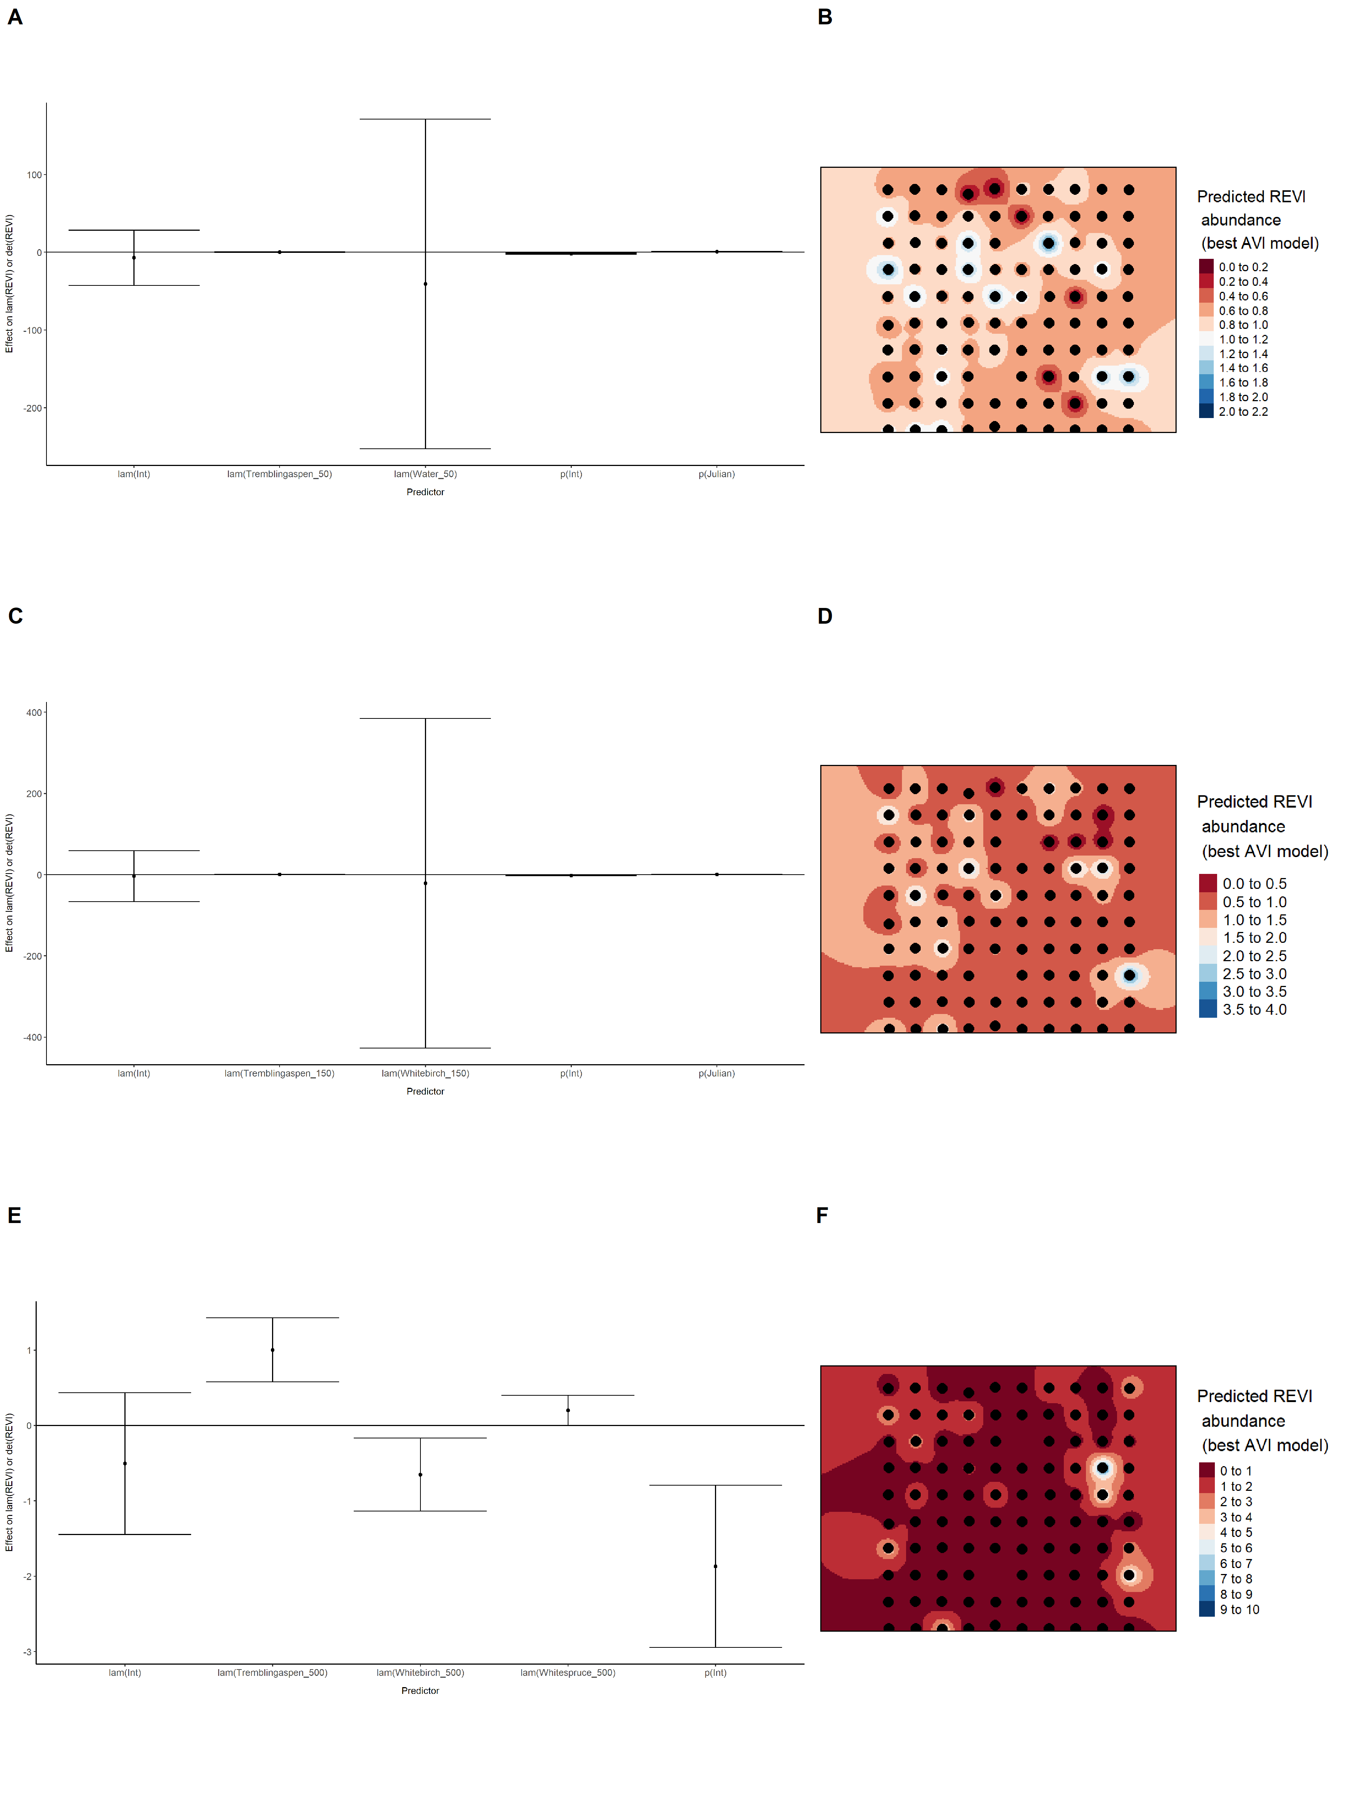

Model coefficients for the best *N*-mixture model predicting abundance of Ruby-crowned Kinglet *Regulus calendula* at the 50-m scale (AIC= 361.96) (A), 150-m scale (AIC= 361.85) (C), and 500-m scale (AIC= 364.5) (E), along with predicted abundances of this species in the Kirby grid from these respective models (B,D,F).

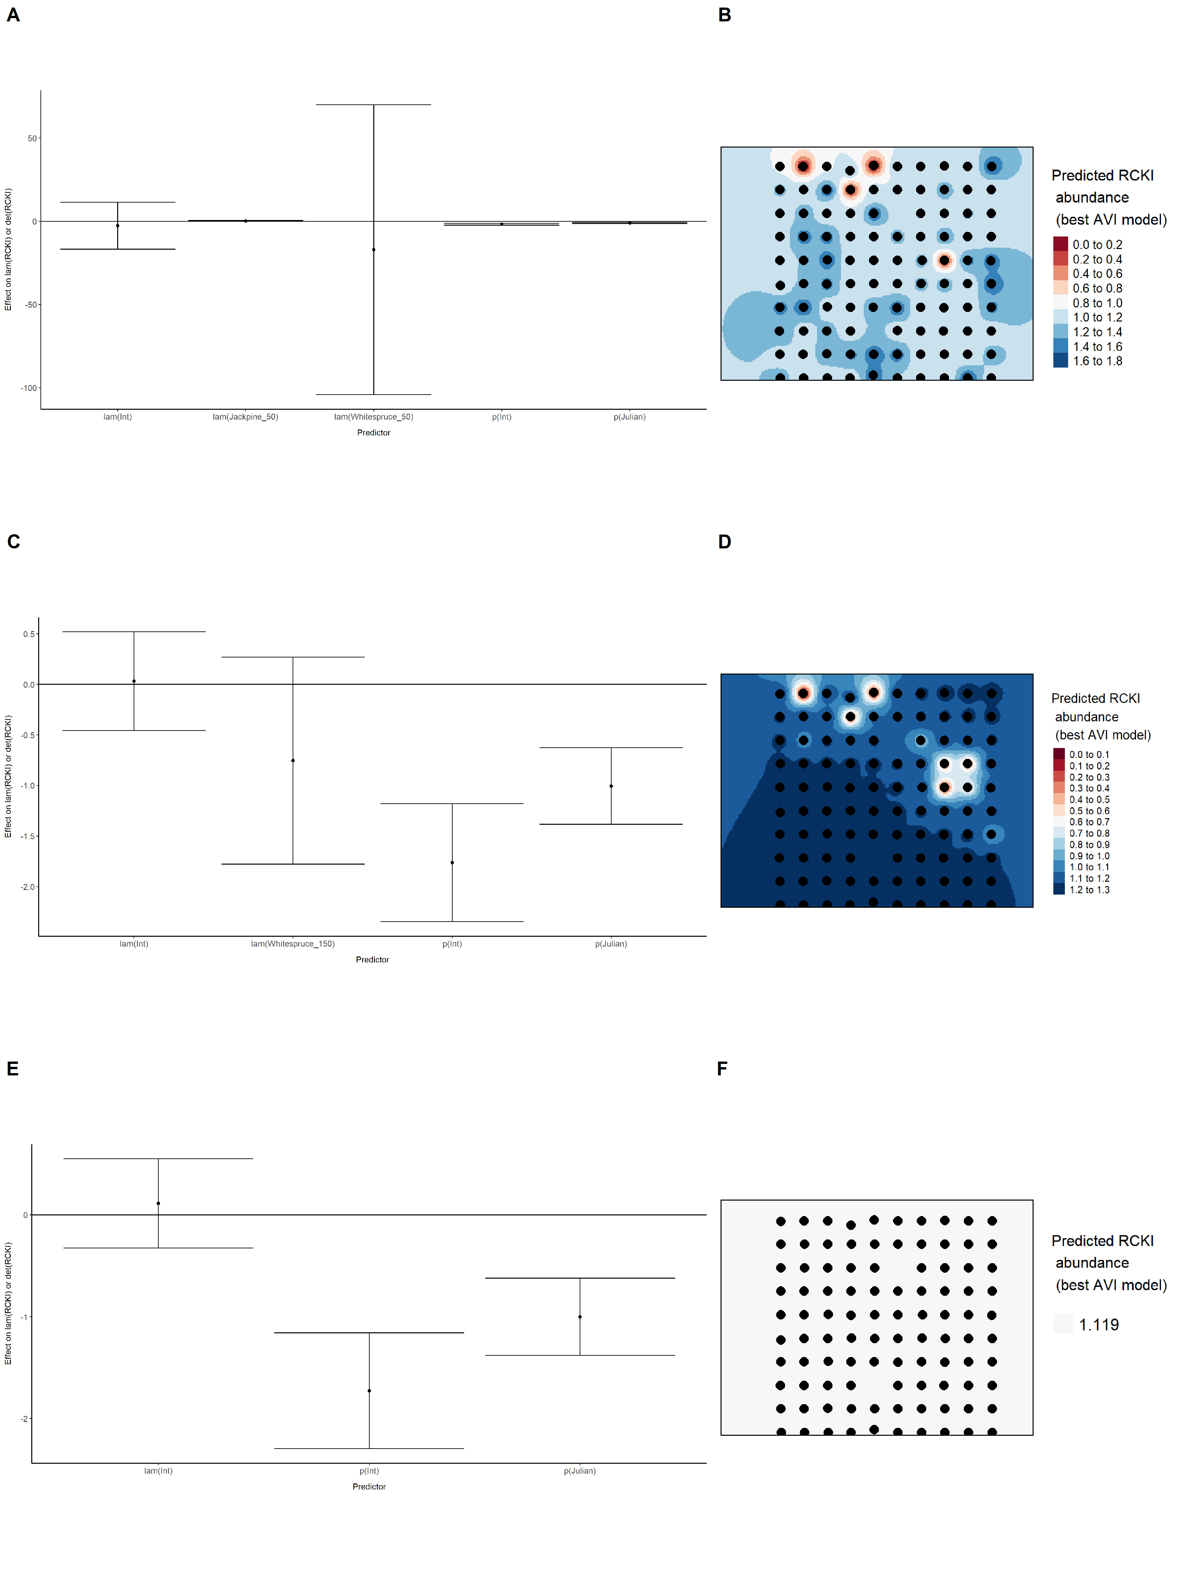

Model coefficients for the best *N*-mixture model predicting abundance of Swainson’s Thrush *Catharus ustulatus* at the 50-m scale (AIC= 665.01) (A), 150-m scale (AIC= 665.64) (C), and 500-m scale (AIC= 664.61) (E), along with predicted abundances of this species in the Kirby grid from these respective models (B,D,F).

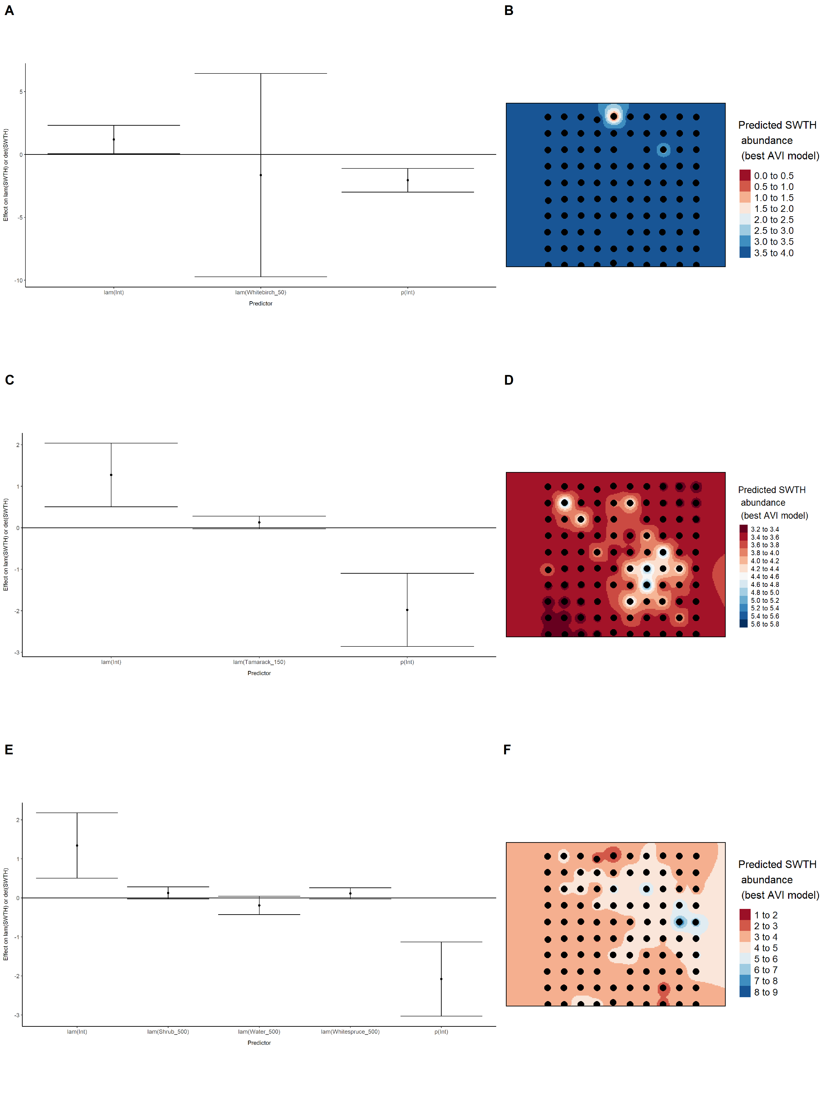

Model coefficients for the best *N*-mixture model predicting abundance of Swamp Sparrow *Melospiza georgiana* at the 50-m scale (AIC= 134.8) (A), 150-m scale (AIC= 127.82) (C), and 500-m scale (AIC= 130.72) (E), along with predicted abundances of this species in the Kirby grid from these respective models (B,D,F).

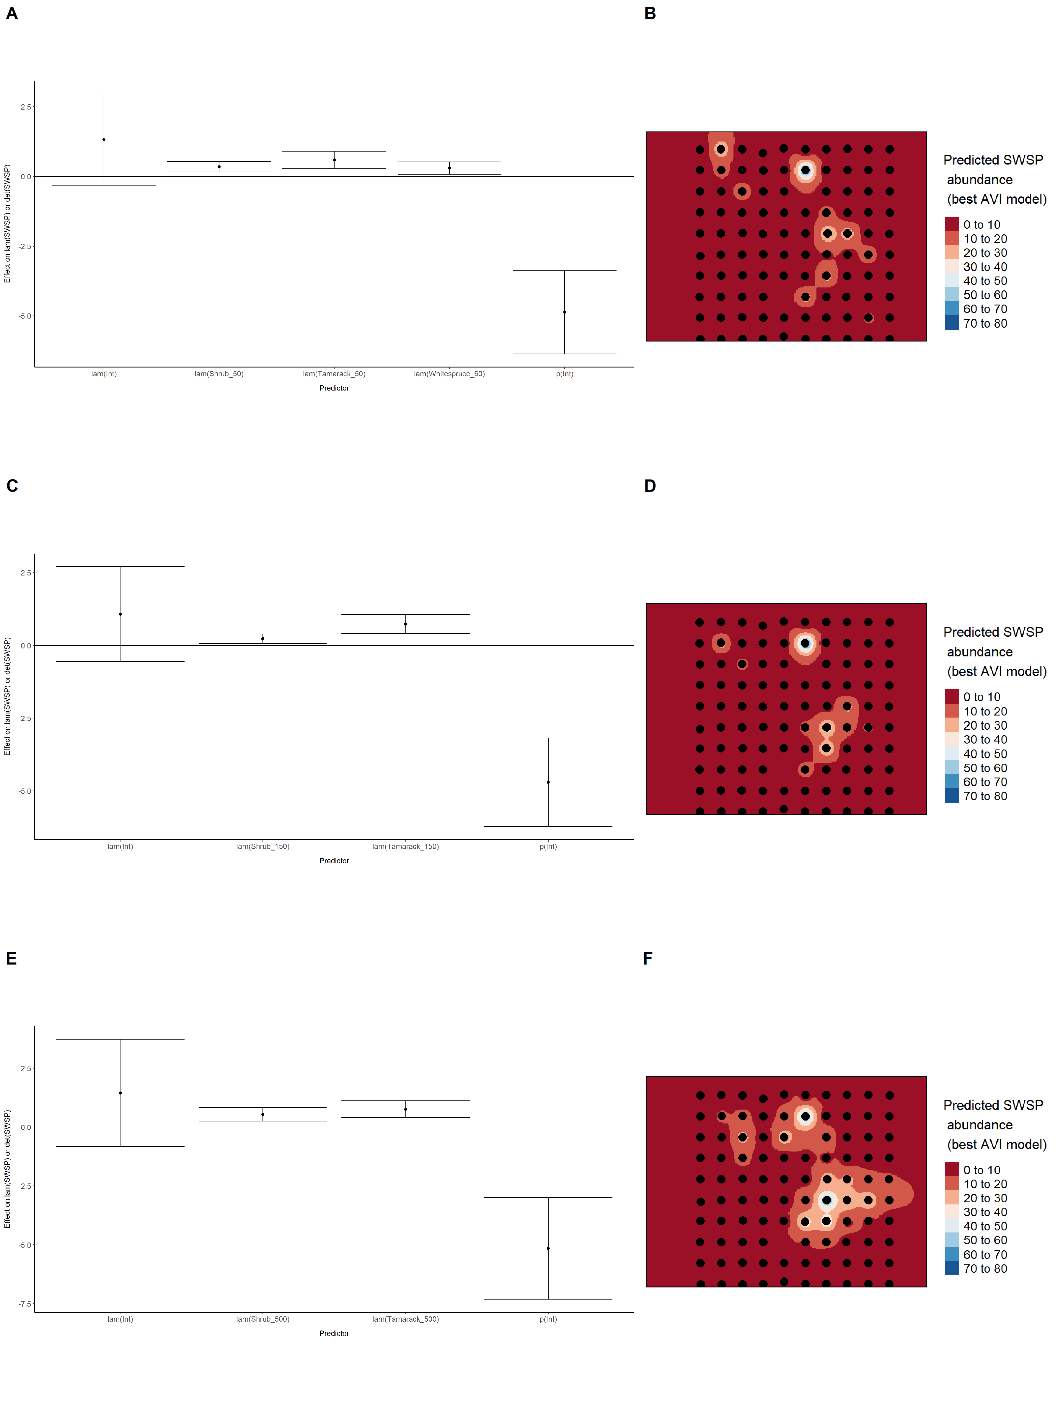

Model coefficients for the best *N*-mixture model predicting abundance of Tennessee Warbler *Leiothlypis peregrina* at the 50-m scale (AIC= 326.99) (A), 150-m scale (AIC= 326.27) (C), and 500-m scale (AIC= 317.57) (E), along with predicted abundances of this species in the Kirby grid from these respective models (B,D,F).

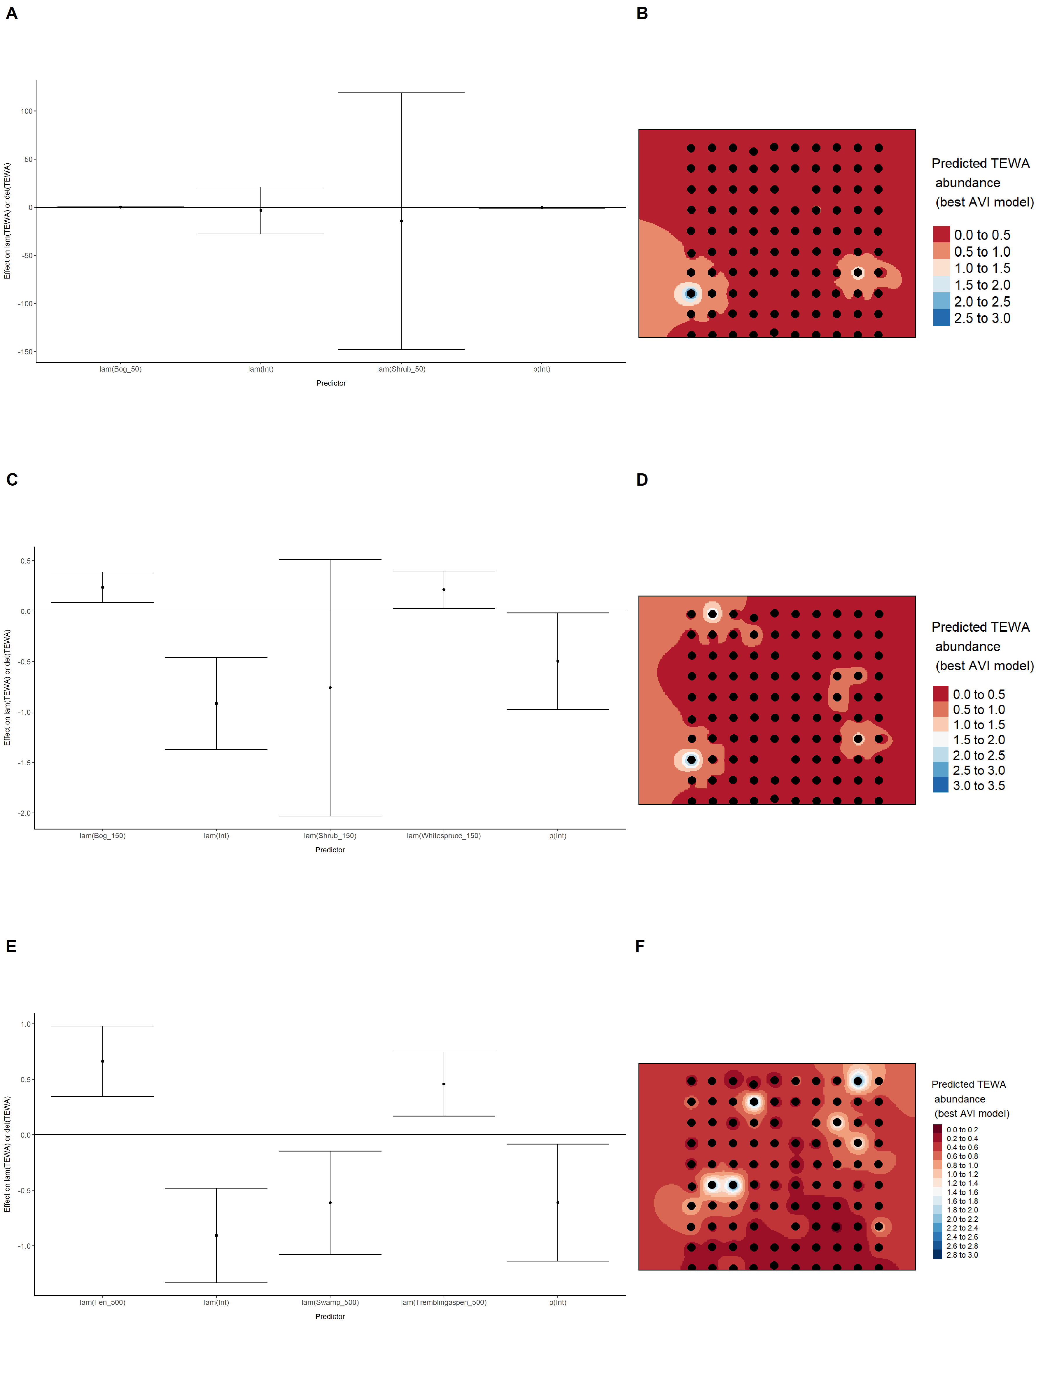

Model coefficients for the best *N*-mixture model predicting abundance of Winter Wren *Troglodytes hiemalis* at the 50-m scale (AIC= 269.22) (A), 150-m scale (AIC= 265.08) (C), and 500-m scale (AIC= 260.39) (E), along with predicted abundances of this species in the Kirby grid from these respective models (B,D,F).

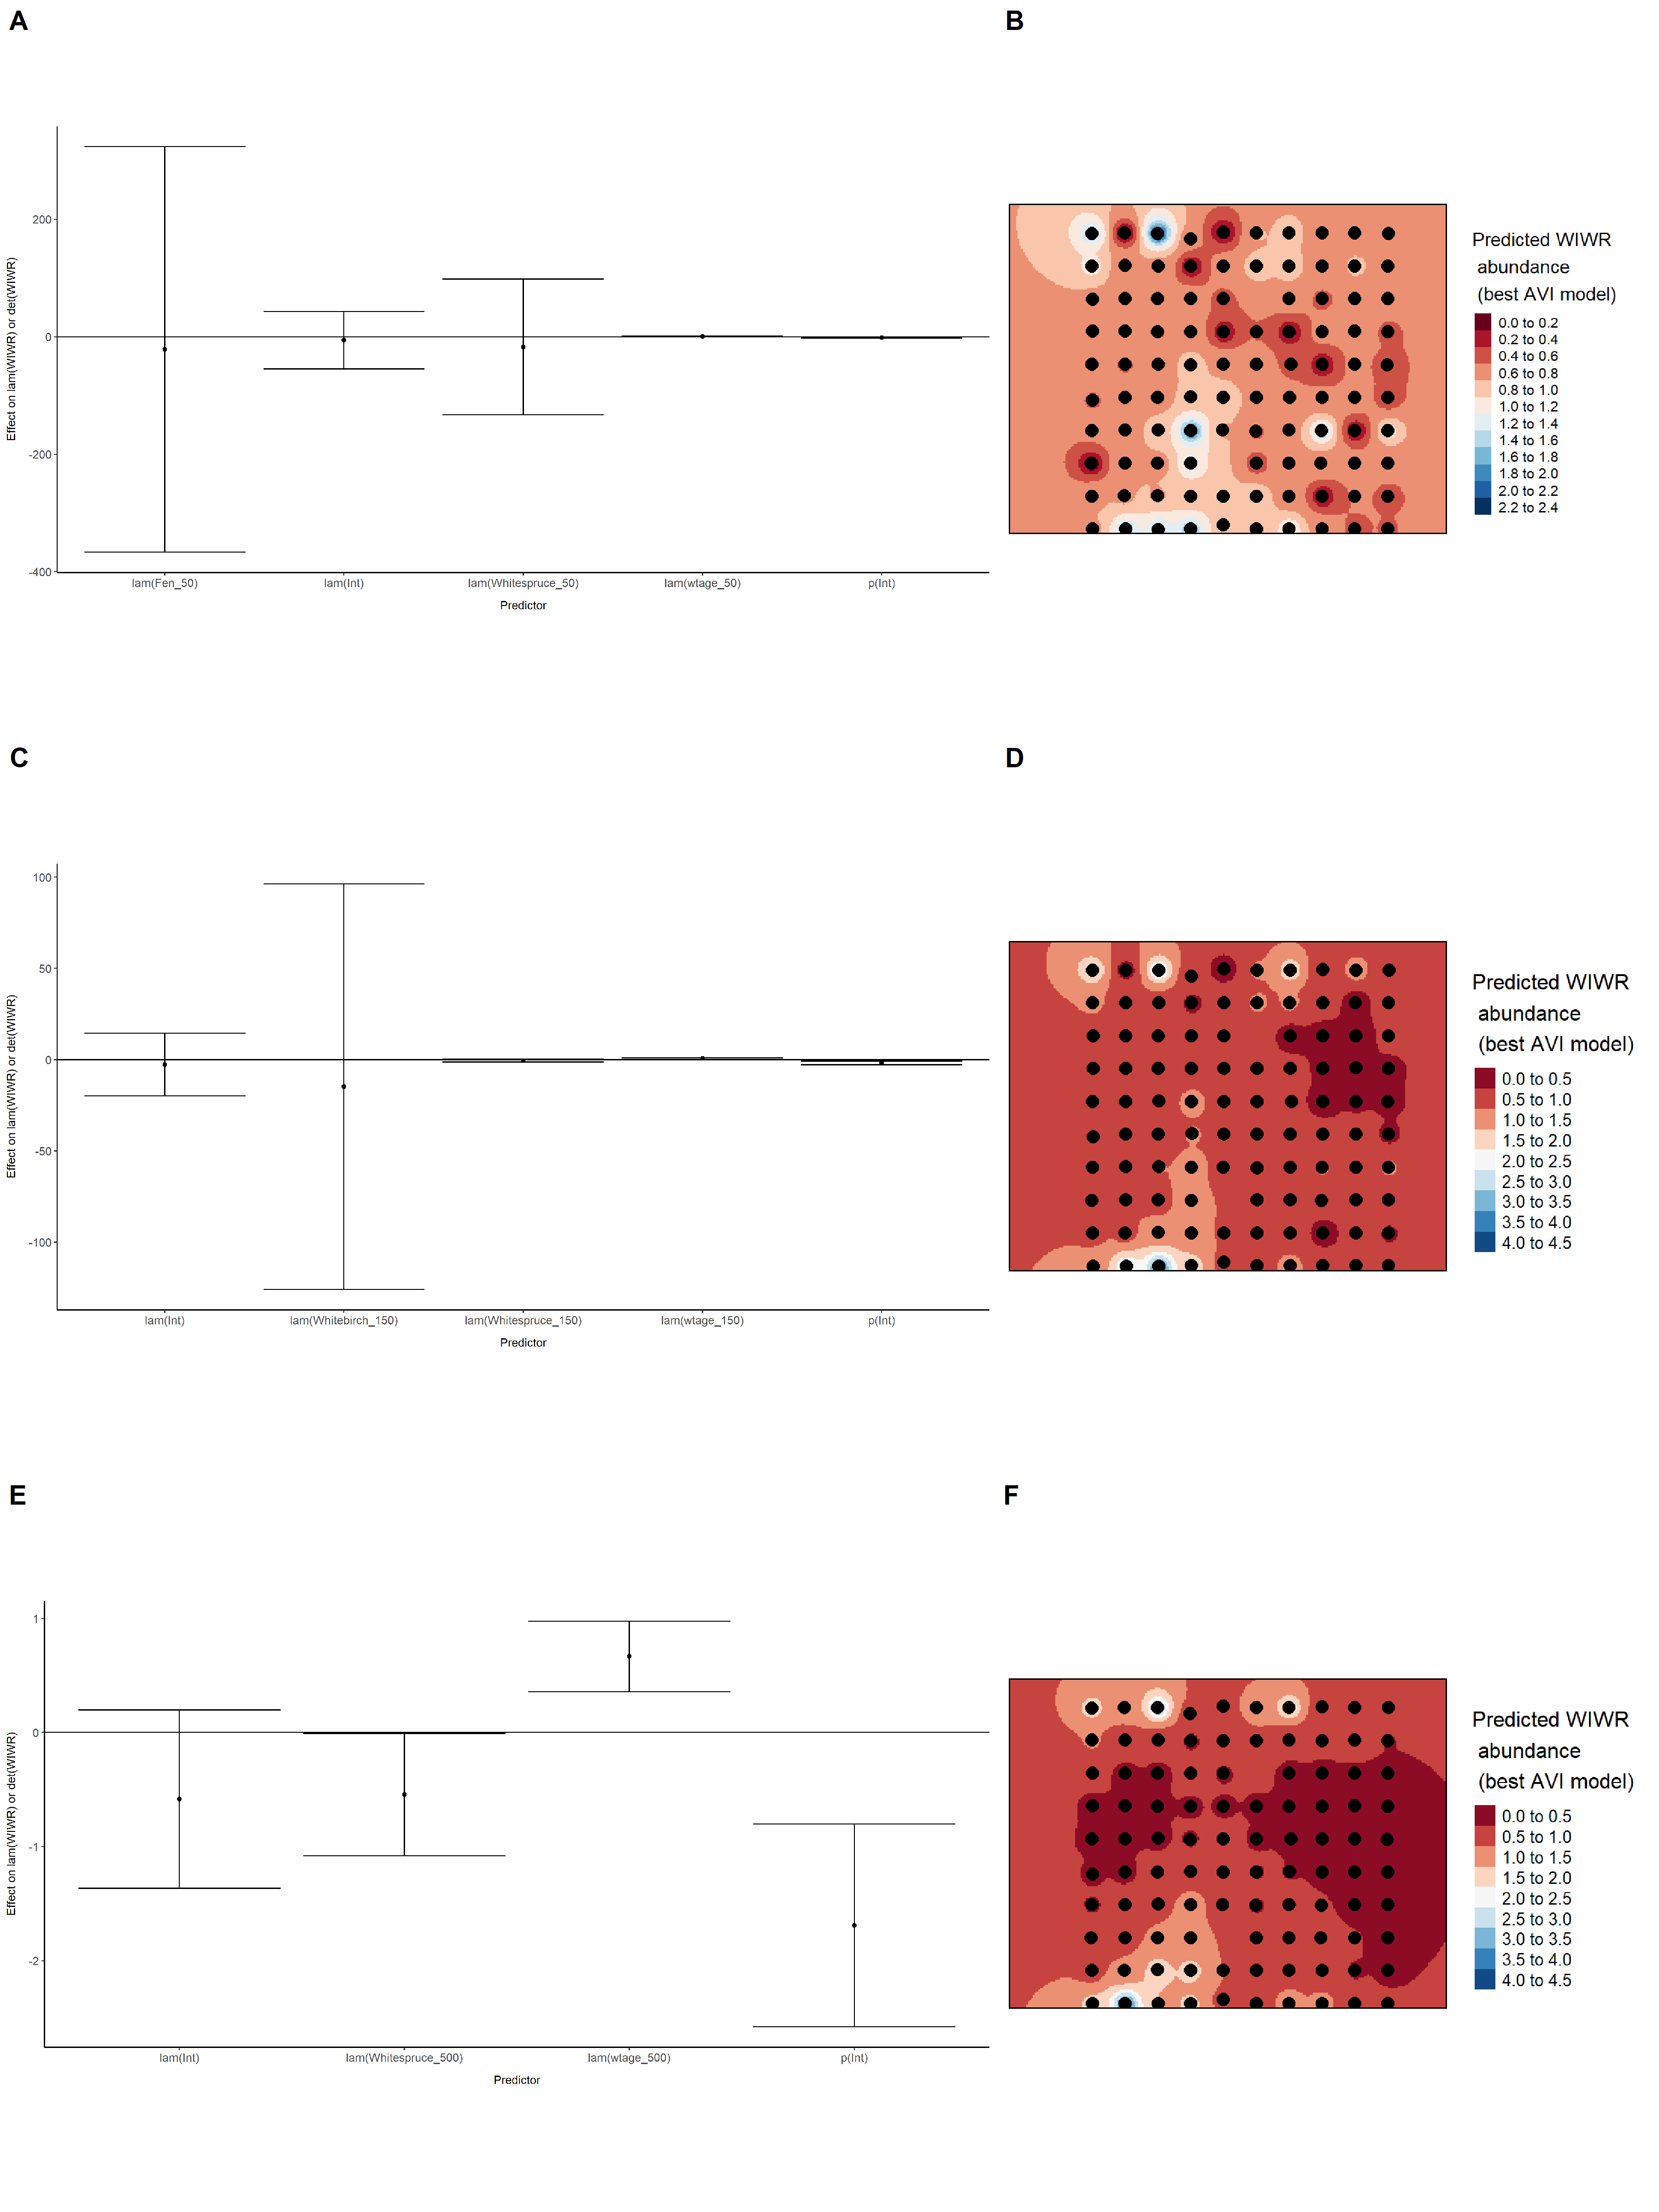

Model coefficients for the best *N*-mixture model predicting abundance of White-throated Sparrow *Zonotrichia albicollis* at the 50-m scale (AIC= 321.48) (A), 150-m scale (AIC= 322.54) (C), and 500-m scale (AIC= 318.9) (E), along with predicted abundances of this species in the Kirby grid from these respective models (B,D,F).

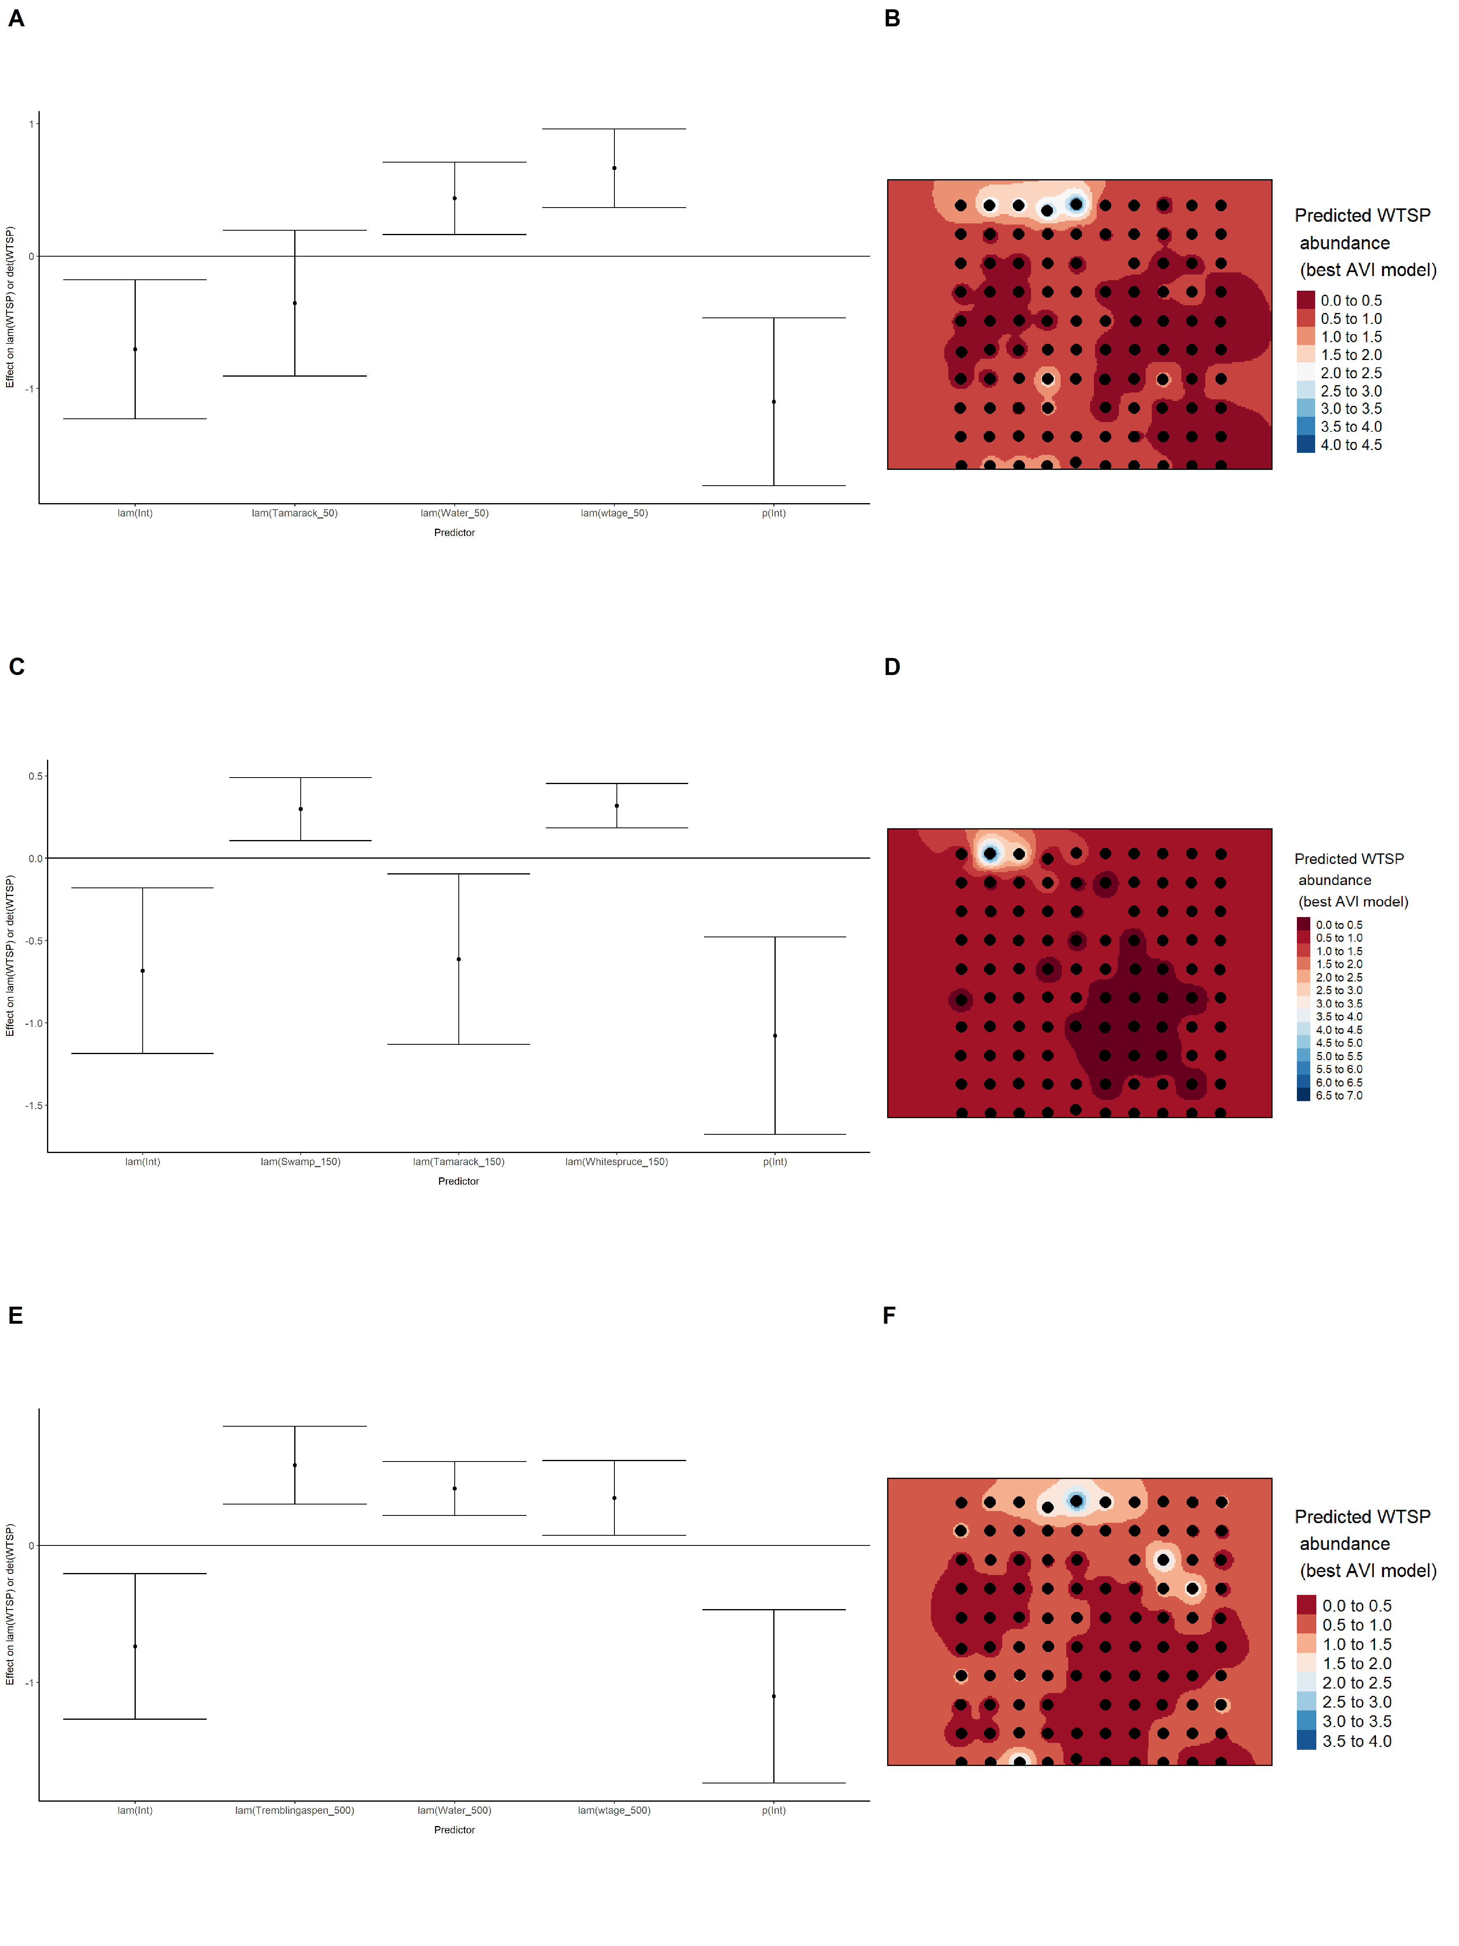

Model coefficients for the best *N*-mixture model predicting abundance of Yellow-rumped Warbler *Setophaga coronata* at the 50-m scale (AIC= 674.11) (A), 150-m scale (AIC= 676.74) (C), and 500-m scale (AIC= 682.45) (E), along with predicted abundances of this species in the Kirby grid from these respective models (B,D,F).

